4-H Talent Showcase
Tuesday, July 25th at 7:00 p.m.
Council Grove High School Auditorium
(HELD IN CONJUNCTION WITH THE 4-H FASHION REVUE)

The Talent Showcase is open to all 4-Hers. 4-Hers DO NOT need to be enrolled in the performing arts project to participate. 4-Hers may exhibit more than one talent showcase entry. Complete one copy of this form per entry. Participants must provide their own props, including musical accompaniment equipment. If you have questions, please call the Extension Office at (620) 767-5136.

Entry forms are due in the Morris County Extension Office Friday, June 30th, 2017 at 5:00 PM.

Name of Participant(s): ________________________________________________________

Club: ________________________________________________________________________

Type of Talent (Vocal Solo, Dance, Ensemble, Dramatics, etc.): _______________________

Time Required: ________________

Please include a brief script to introduce your talent showcase entry (2-5 Sentences): ___

_____________________________________________________________________________

_____________________________________________________________________________

_____________________________________________________________________________

_____________________________________________________________________________

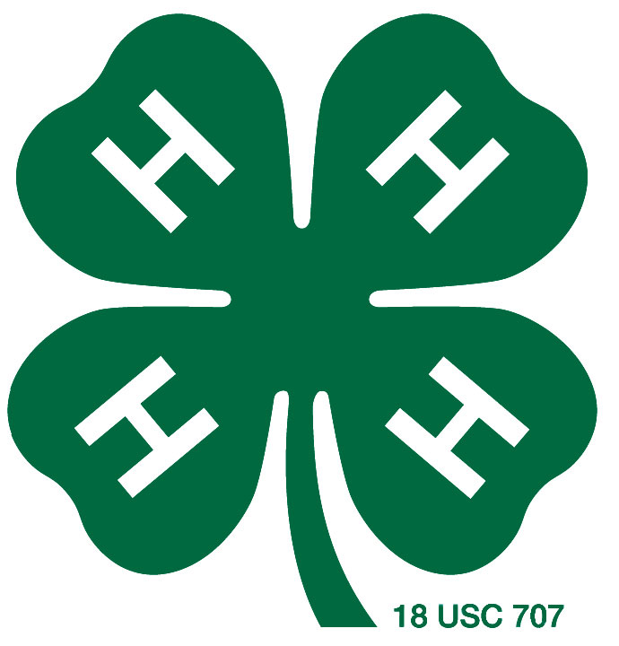

“K-State Research and Extension is an equal opportunity provider and employer.”

