Thank You Note Expectations and Policies
A great deal of time, energy, and money contribute to the success of the fair and support of the Morris County 4-H Program and 4-Her’s. This year, in an effort to properly thank our sponsors and buyers, specific thank you policies are being put in place.
Sponsors of Awards
A blank thank you note and envelope will be attached with all awards and trophies. They will be specially addressed and marked for the award which has been sponsored; the 4-Her is expected to write his/her thank you note on the stationary provided and then turn it in to either the box at the Thank You Note Booth during the Fair or to the Extension office in the 30 days following the fair. DO NOT mail them directly to the sponsor. Names will be checked off of the list to assure that ALL sponsors receive their thank you note. All Thank You notes are due to the Extension Office by August 30, 2019 at 5 PM. If the sponsor thank you notes are not turned in to the Extension office, the 4-Her forfeits their ribbon premium funds. If the thank you is lost, check with Shandi or Laci for sponsor information. Blank Thank You notes will be available at the Thank You Note Booth. A list of ideas to include in your thank you:
- Sincerely thank the sponsor for the award you received and their generosity
- Share your favorite part of the project this year
- Share one or two interesting things you learned this year
Foods Auction
A thank you note must be included with your foods box at the check-in table by 9:30 AM on Saturday. Boxes without a thank you note will not be sold. A list of ideas to include in your thank you:
- Sincerely thank the buyer for the purchase of your foods box
- Share one or two interesting things you learned this year
- What makes your recipes or foods in the box special?
- Invite them to come back next year
Livestock Premium Auction
Following the sale of your market animal, you will receive a buyer’s ribbon and a colored postcard labeled ‘Morris County Fair Livestock Sale Thank You Verification’.
The buyer’s ribbon can either be directly handed to the buyer that night with a verbal “thank you” or can be delivered at a later date with your hand-written thank you.
The colored postcard labeled ‘Morris County Fair Livestock Sale Thank You Verification’ will have yours and your buyer’s information on it. When a thank you has been hand-delivered to the buyer within the 30 days following the sale, ask the buyer to sign, and the 4-Her should return the postcard to the Extension Office. This should NOT be signed by the buyer the night of the Premium Auction. If you would like to deliver a token of appreciation like cookies, goodies, or a small gift this is the time to do so. Please do not deliver goodies to the buyers the night of the auction. Thank you verification forms are due to the Extension Office by August 30, 2019 at 5 PM so checks can be processed when funds are made available. If the Thank You verification is not turned in to the Extension office by the deadline, the 4-Her forfeits their livestock premium funds.
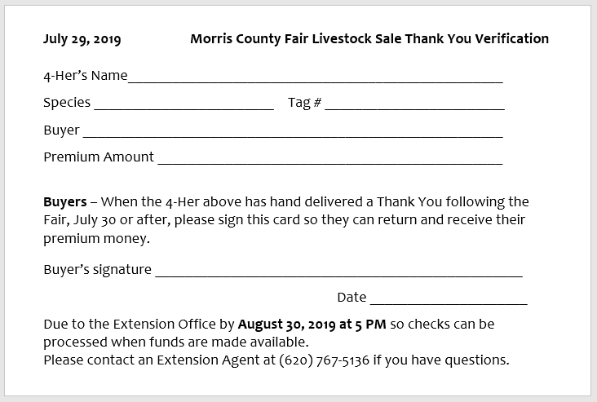
When you write your thank you note, be sincere and express your appreciation. A list of possible ideas to include in your thank you note are:
- Sincerely thank buyer for purchase of your animal
- You might share specific plans you have for use of the sale proceeds
  - Purchase of next year’s project animal
  - Saving for education after high school
  - Enrolling in and exploring other 4-H project offerings
- Share one or two interesting things you learned about this year
- Invite them to participate in future Stock Sales
  - Even if you are graduating, other members could benefit from their support
A sample of the Thank You Verification is printed below:

Thank You Note Booth
The Thank You Note Booth will be set up in the Concession Stand area of the Fair building. Blank thank you notes will be available. Please take the time to write a thank you to those who have supported you during this 4-H year. There will be a box to place Sponsor thank you notes in.
All thank you notes should be turned in to the Extension Office by August 30, 2019 at 5 PM.
Premium checks will be written once Laci has received notification that funds have been released to write checks.

