

Sun | Mon | Tue | Wed | Thu | Fri | Sat
 |  |  |  |  |  | 1
2 | 3 | 4 | 5 | 6 | 7  4-H Foundation  Banquet | 8  Beef Weigh-in  8-9am @ Schrader’s  
9  Cloverbud Meeting 3-4pm | 10 | 11 | 12 | 13  Cat Project Meeting 6pm | 14  Office Closed   | 15
16   | 17 | 18 | 19 | 20 | 21 | 22
23 | 24  7pm 4-H Council  -Ambassador Mtg. After | 25 | 26 | 27 | 28 | 29
30
Small Animal Weigh-in
4-5:30p.m.
@Fairgrounds


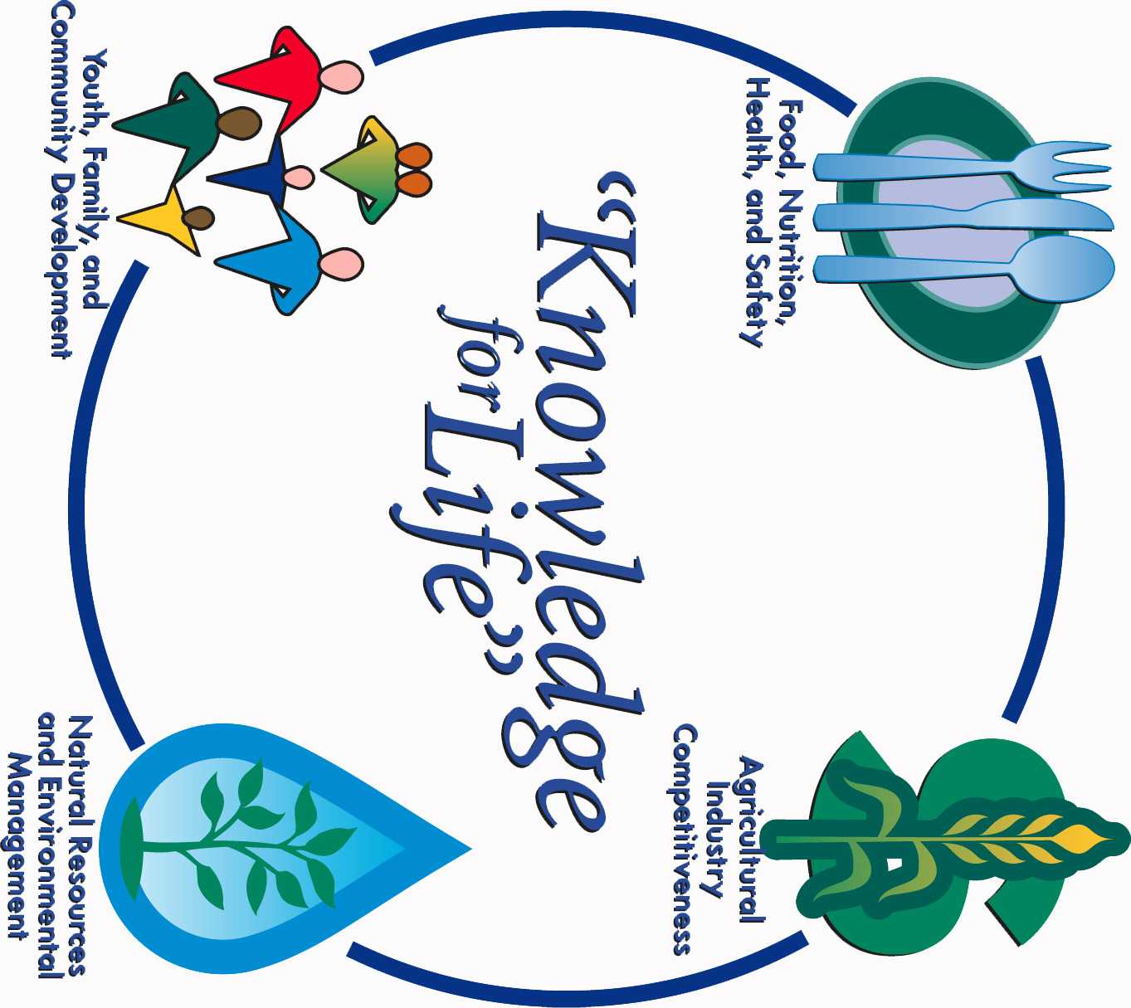
COOPERATIVE EXTENSION SERVICE
Morris County Extension Office
Courthouse – 501 West Main
Council Grove, KS 66846-1796
620-767-5136

APRIL 2017 4-H NEWSLETTER
Morris County
Flint Hills Extension District

Lori Bammerlin Allicia Ochoa
Agent, Agriculture/4-H Office Professional

Kansas State University
Agricultural Experiment
Station & Cooperative
Extension Service
K-State County Extension
Councils, Extension Districts
& U.S. Department of
Agriculture Cooperating
All Educational programs and
Materials available without Discrimination on the basis
Of race, color, religion, national
Origin, sex age or disability

