

Sun | Mon | Tue | Wed | Thu | Fri | Sat
 |  | 1 | 2 | 3 | 4 | 5
6 | 7 | 8  State Fair Encampment Building Reservations & Advanced Fair Tickets Form Due | 9 | 10  State Fair Entries Due Today | 11 | 12
13 | 14 | 15 | 16 | 17 | 18 | 19  Livestock Sweepstakes
20 | 21  4-H Council Meeting @ 7 PM followed by Ambassador Meeting | 22 | 23 | 24 | 25 | 26
27 | 28 | 29 | 30 | 31


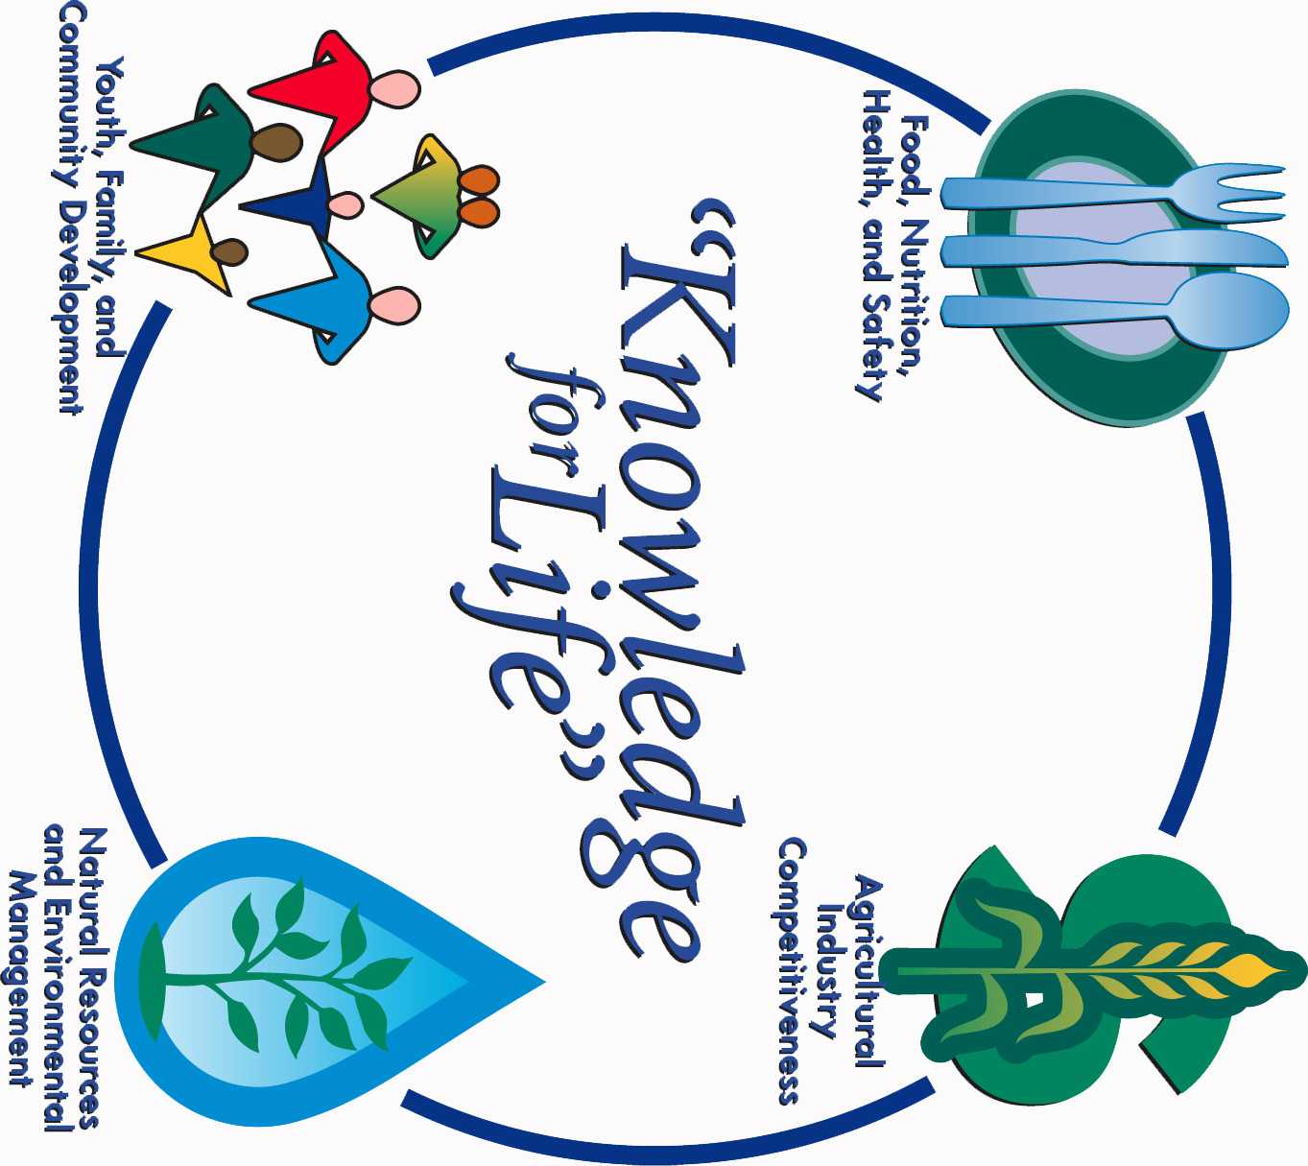

Morris County Extension Office
Courthouse – 501 West Main
Council Grove, KS 66846-1796
620-767-5136

AUGUST 2017 4-H NEWSLETTER
Morris County
Flint Hills Extension District

Lori Bammerlin Shandi D. AndresAlisa Mossman
Agent, Agriculture/4-H Agent, Family & Consumer Office Professional
Sciences/4-H

Kansas State University
Agricultural Experiment
Station & Cooperative
Extension Service
K-State County Extension
Councils, Extension Districts
& U.S. Department of
Agriculture Cooperating
All Educational programs and
Materials available without Discrimination on the basis
Of race, color, religion, national
Origin, sex age or disability

