August 2017

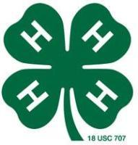

2017 Morris County Fair
Thank you to the Morris County Fair Board, 4-H members and families, and numerous fair supporters for making the 2017 Morris County Fair a success. Congratulations to the 4-Hers for their hard work which resulted in a great display of projects at fair. Be sure to thank all of your buyers and fair sponsors! For your convenience, the names and addresses of the award sponsors are listed on the bottom of the trophies or on the envelopes of the cash awards.
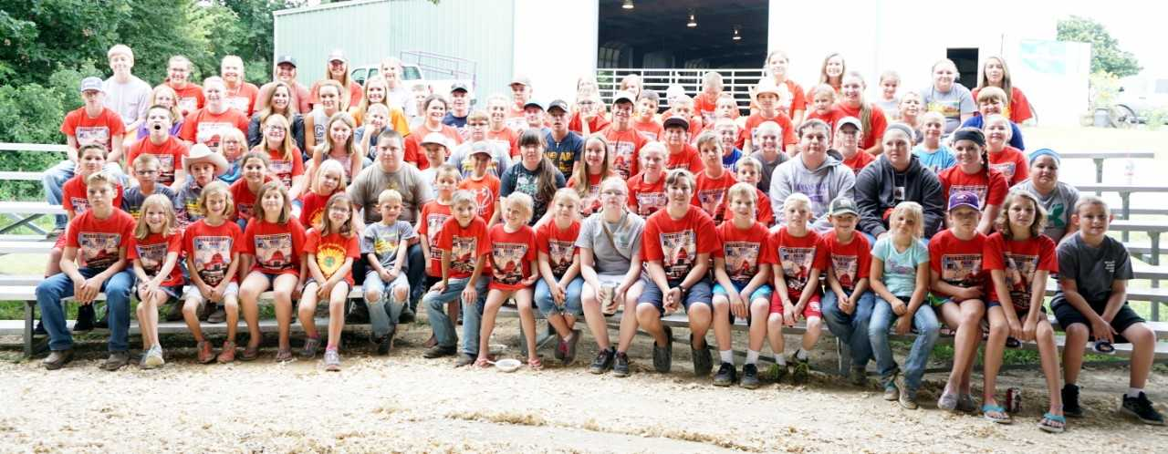

4-H Council Meeting
The next 4-H Council meeting will be held on Monday, August 21st in the Morris County Courthouse meeting room at 7:00 p.m.

Ambassador Meeting
The next Ambassador meeting will be held on Monday, August 21st in the Courthouse meeting room following the 4-H Council meeting.

Kansas State Fair
Pre-Entry Deadline
The 2017 Kansas State Fair will be held Friday, September 8th through Sunday, September 17th. The pre-entry deadline for exhibits is August 10th. In order to exhibit projects at the Kansas State Fair, 4-Hers must be 9 years old by January 1, 2017. Livestock entries must have met nomination deadlines and show entry deadlines. For all other projects, 4-Hers must receive a purple ribbon at the county fair and there must be a class available at the State Fair. The only exception is in visual arts; Morris County is allowed three exhibits and those were identified by the judge.
4-H families may order youth and adult admission tickets to the Kansas State Fair in advance through the Extension Office. Ticket prices are as follows: youth (ages 9-18) - $3; adult (ages 13-59) - $7; and senior (ages 60 and over) - $4. Encampment Building reservations ($15 per person per night) and parking lot hang tags (4-Hers exhibiting livestock, horses, and dogs) purchases can also be made through the Extension Office. Reservations, orders, and payment need to be submitted by August 8th.

Talent Showcase Winners
Congratulations to Morgan Poole for her performance of the song “Simple” with her mandoline winning this years’ Talent Showcase. Second place went to Samuel Barr for his piano performance.
Sunny Hills Camp Photos
While at 4-H camp this summer, photos were taken of each camp living group. If
4-Hers would like to have a copy of their living group photo, please email Lori at bammerlin@ksu.edu. She will be happy to email a copy to you.

Kansas State Fair Exhibits
Exhibits for the Kansas State Fair need to be brought to the Extension Office by Thursday, September 7th. Food and horticulture items may be delivered to the office between 7:30 a.m. and 8:30 a.m. on Friday, September 8th.

4-H Buyers Certificates
If you sold the grand champion or the reserve grand champion market animal at the Morris County Fair during the livestock premium sale, a buyer’s certificate has been made for you to deliver. They are available in the Extension Office for pick up.

Lost and Found
We have a few clothing and livestock items in the Extension office that were left at the fairgrounds following the Morris County Fair. Please call or stop by to claim your items.

Round Robin and Livestock Judging Contest Results Available
If the participants in the Round Robin Showmanship Contest or the Livestock Judging Contest would like to see the scorecard results, they are available in the Extension Office. You can stop by the office or we can scan and email them to you upon your request.

2017 Beef Stocker Field Day
The KSU Beef Stocker Field Day will be held on Thursday, September 21 at the KSU Beef Stocker Unit. We’ll offer practical information and management tips to help you achieve greater flexibility and optimize your stocker operation in the evolving beef industry. We will be serving a barbeque brisket lunch. The day will conclude with a good old-fashioned prairie oyster fry. Online registration information can be found at www.KSUbeef.org

FCS Judging Contest Results
Congratulations to Carissa Dalquest (Junior Division) and Treyser King (Senior Division) for winning the Family and Consumer Sciences Judging Contest that was held in conjunction with the Clothing and Fashion Revue judging at the fair!

Photography Judging
Contest Results
Congratulations to Ella Kirk (Intermediate Division) and Morgan Poole (Senior Division) for winning the Photography Judging Contest that was held at the fair! Ella Kirk, Rylee Powell, Cassidy Dalquest, and Mandy Wainwright will have the opportunity to represent Morris County as the intermediate team in the Photography Judging Contest at the Kansas State Fair. Morgan Poole, Treyser King, Jess Prudence, and Dryden Powell will also have the opportunity to compete at the State Fair as the senior team. Thank you to all who participated, from 8 years and under to adults. Junior Division (8 years & under) can’t qualify for state fair but we still want to recognize Laramie Mayer for placing 1st. Adults also had the opportunity to participate; Mary Ellerman placed 1st.
Record Book Reminders
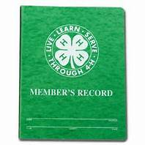
Record books and pin applications are due in the Extension Office by Monday, October 2nd. Forms are online at: www.flinthills.ksu.edu.
As you are preparing your record books, please remember the following:

*Junior Division (7 & 8 Year Olds) – When writing stories for your award applications, remember to include two stories. One story should be a general 4-H story that describes your 4-H year. The second story should be a project story that describes your project work throughout the year.

*Intermediate Division (9-13 Year Olds) and Senior Division (14 & Older) – When writing your stories for your KAPs, remember that your story needs to be project specific. You may include information from your 4-H year as it relates to your project.

*Permanent Records – Remember that the permanent record is a continuous document of the activities throughout your 4-H career. In other words, the current year’s activities should be added to the previous year’s document.

*Application Signatures – Remember to have your award applications and pin applications signed by your club leaders and a parent/guardian.

An order of assembly for record books is now posted on our website. If you have questions about completing record books, filling out pin award applications or what pin application you can apply for, please contact the Extension Office.

4-H Key Award
4-Hers who are 16 years old or older may apply for the 4-H Key Award. Requirements for the award include completing at least four years of 4-H work, being enrolled in the leadership project for at least four years, and fulfilling at least nine other requirements on the application. The application can be found on the Flint Hills District website at flinthills.ksu.edu. Once at the website, click on the 4-H Youth Development tab on the left-hand side of the screen and then click on the Morris County Information tab. Applications are due Monday, October 2nd.

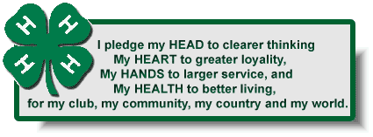
Achievement Banquet
The annual 4-H Achievement Banquet will be held on Saturday, November 11th in the community building at the fairgrounds.

Mark Your 2017 Calendars
Aug 8 – State Fair Advance Tickets Due
Sept 8-17 – Kansas State Fair
Sept 29 – Oct 1 - KJLS
Oct 2 – Record Books, Pin Applications & Key Award Applications Due
Nov 11- Achievement Banquet

as you head back to School,
we extend our best wishes for a successful school year!!


