

Sun | Mon | Tue | Wed | Thu | Fri | Sat
 |  |  | 1 | 2 | 3 | 4
5 | 6 | 7 | 8 | 9 | 10 | 11  Kansas 4H Day with Wildcat Women @1p.m.
12 | 13 | 14  Valentine’s Day   | 15 | 16  Cloverbud Meeting 6-8p.m | 17  Club Day Entry Deadline | 18
19 | 20  Extension Office Closed  6p.m. -  Cat Project Mtg.  7p.m. 4-H Council mtg.  *Ambassador mtg to follow | 21 | 22 | 23 | 24 | 25
26 | 27 | 28

---Ambassador Training---

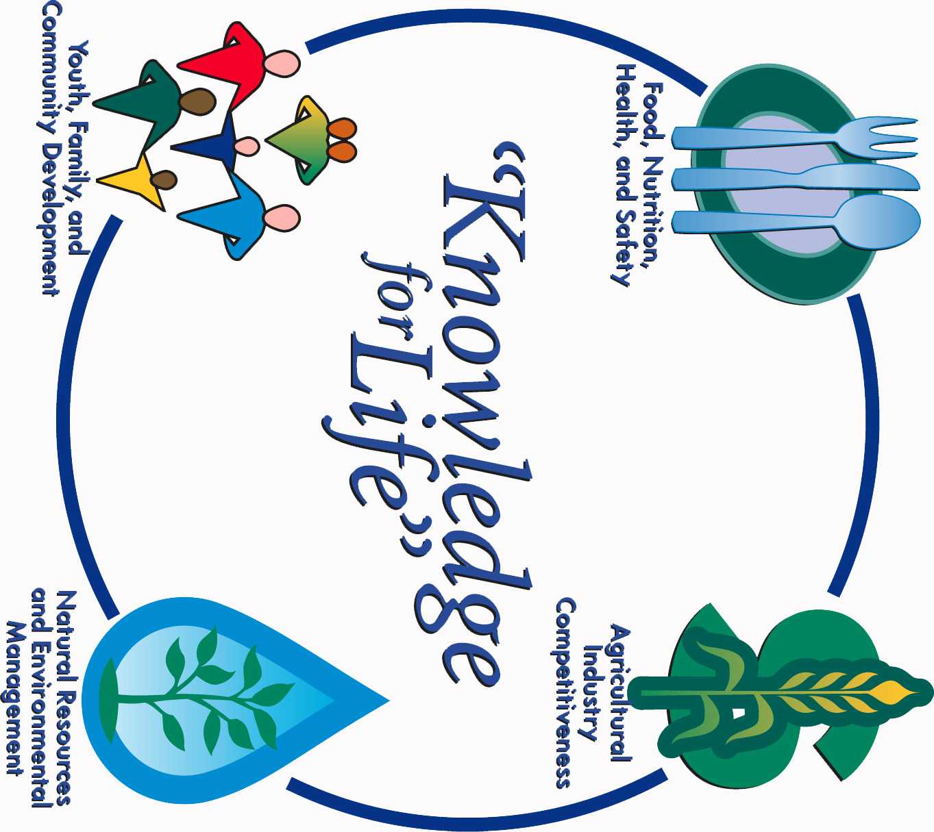
COOPERATIVE EXTENSION SERVICE
Morris County Extension Office
Courthouse – 501 West Main
Council Grove, KS 66846-1796
620-767-5136

February 2017 4-H NEWSLETTER
Morris County
Flint Hills Extension District

Lori Bammerlin Allicia Ochoa
Agent, Agriculture/4-H Office Professional

Kansas State University
Agricultural Experiment
Station & Cooperative
Extension Service
K-State County Extension
Councils, Extension Districts
& U.S. Department of
Agriculture Cooperating
All Educational programs and
Materials available without Discrimination on the basis
Of race, color, religion, national
Origin, sex age or disability

