

Sun | Mon | Tue | Wed | Thu | Fri | Sat
 |  |  |  |  |  | 1
2 | 3  Office Closed | 4  Office Closed   | 5  District Horse Show | 6 | 7 | 8
9 | 10 | 11  Cat Meeting  @ 6 p.m. | 12 | 13 | 14 | 15  Food Preservation Class 9am-4pm
16 | 17 | 18  Cat Meeting  @ 6 p.m. | 19 | 20 | 21 | 22  Dog Show
23  30  Photography Judging Contest/ Judging of Photography  Sheep &  Meat Goat Show | 24  ____________  31  Round Robin, Barnyard Olympics, Awards,  Livestock Sale, Release of All Exhibits | 25  Clothing Judging,  Style Revue, and Talent Show | 26  Hand Pet & Cat Shows  Fairgrounds clean-up/set up  4-H & Open Class Entries Accepted | 27  4-H & Open Horse Show | 28  Check-in of  4-H and Open Class Exhibits and Livestock Entries | 29  Check-in of Food, Horticulture, Floriculture Exhibits (7-9 AM)  Swine Show  Beef Show & Bucket Calf Costume Parade

Leadership Unlocked July 16-18
Morris County Fair
July 22-31
Tri County Fair July 6-8

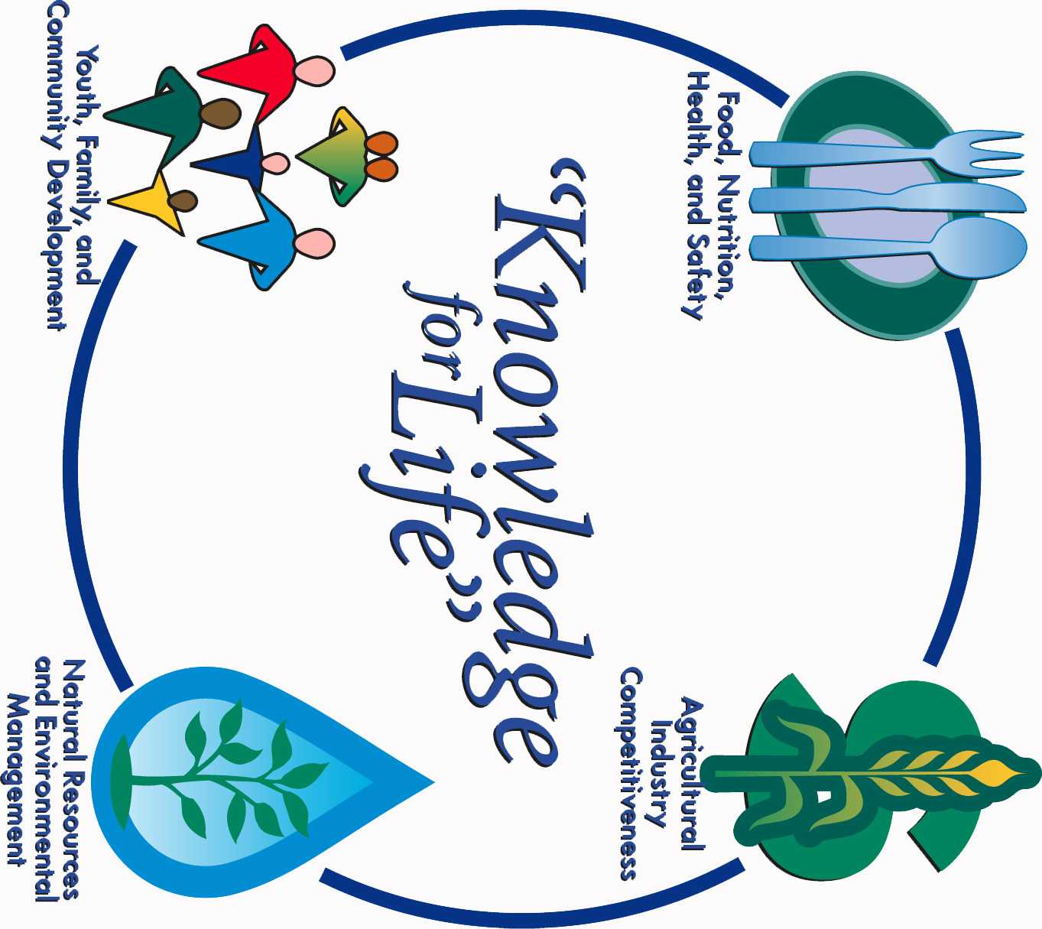

Morris County Extension Office
Courthouse – 501 West Main
Council Grove, KS 66846-1796
620-767-5136

JULY 2017 4-H NEWSLETTER
Morris County
Flint Hills Extension District

Lori Bammerlin Shandi D. AndresAllicia Ochoa
Agent, Agriculture/4-H Agent, Family & Consumer Office Professional
Sciences/4-H

Kansas State University
Agricultural Experiment
Station & Cooperative
Extension Service
K-State County Extension
Councils, Extension Districts
& U.S. Department of
Agriculture Cooperating
All Educational programs and
Materials available without Discrimination on the basis
Of race, color, religion, national
Origin, sex age or disability

