July 2017

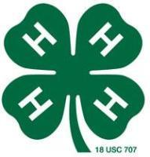


4-H Council Meeting
The next 4-H Council meeting will be held Wednesday, July 26th in the fair building after fair set up.

4-Hers Attend Discovery Days
Thirteen 4-Hers in the Flint Hills District attended Discovery Days, May 30 – June 2.
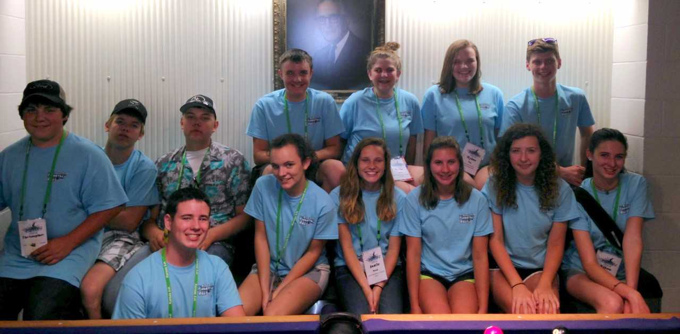

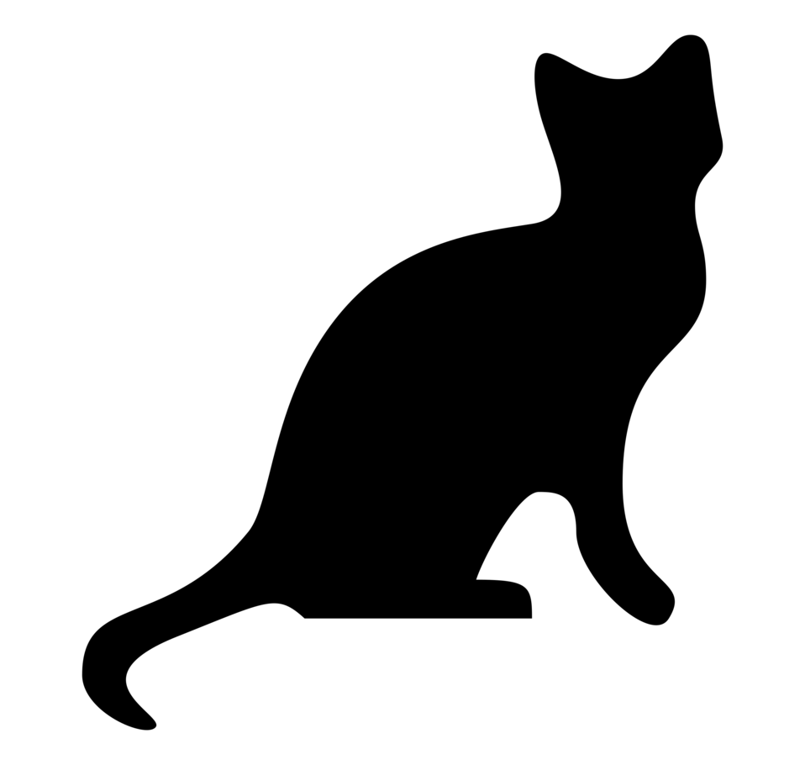
County Cat Project Meeting
There will be a county cat project meeting in the Courthouse meeting Room on Tuesday, July 11th and Tuesday, July 18th at 6:00 p.m.
Bring your cat! This will be a mock cat show to practice for the fair.

Tri-County Fair
The Tri-County Fair will be July 6th – 8th in Herington, KS. The fair will include 4-H exhibitors from Morris, Marion, and Dickinson counties. Fair papers, which include the fair guidelines and schedule, as well as entry cards are now available to be picked up in the Extension Office.

Washunga Days Parade
Neosho Valley 4-H Club: “4-H IS REALLY SWEET”
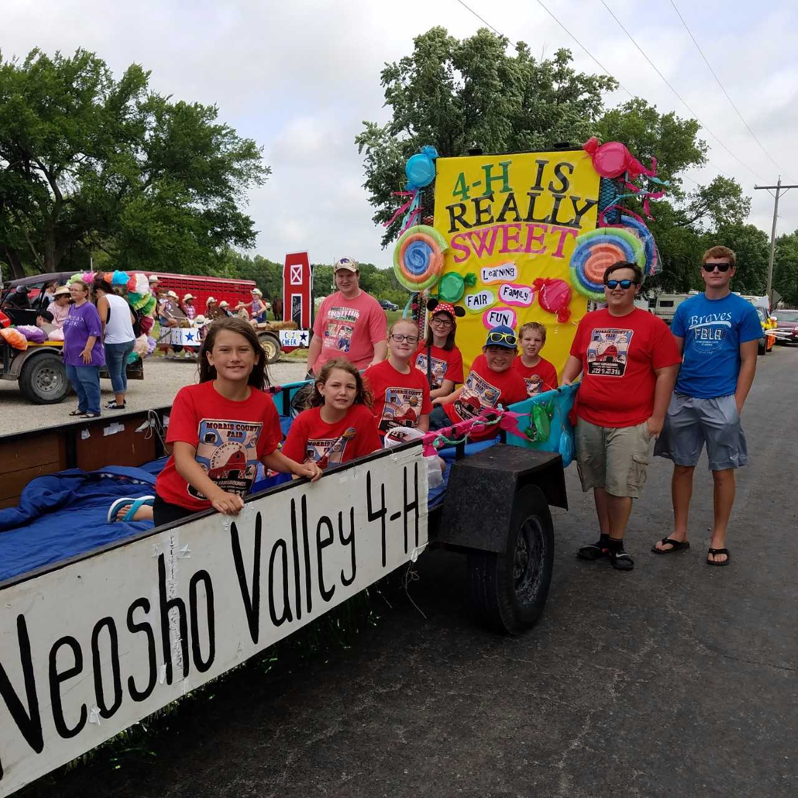
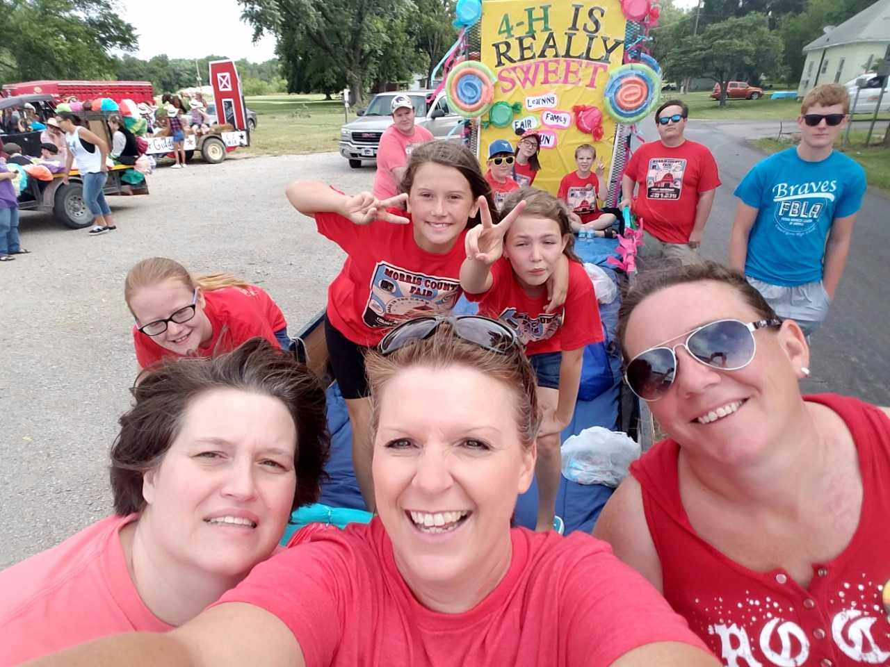
Members of the cat and pets project participated in the Washunga Days Parade. Members decorated the float promoting the cat and hand pet show during the fair. The project members included are: Alex Priest, Leo White, Apollo & Zeke Moore, Justine & Avery Lee, Kaylee & Fayth Ehrlich, Laura Buller, and Rowdy & Jaylee Benedick.
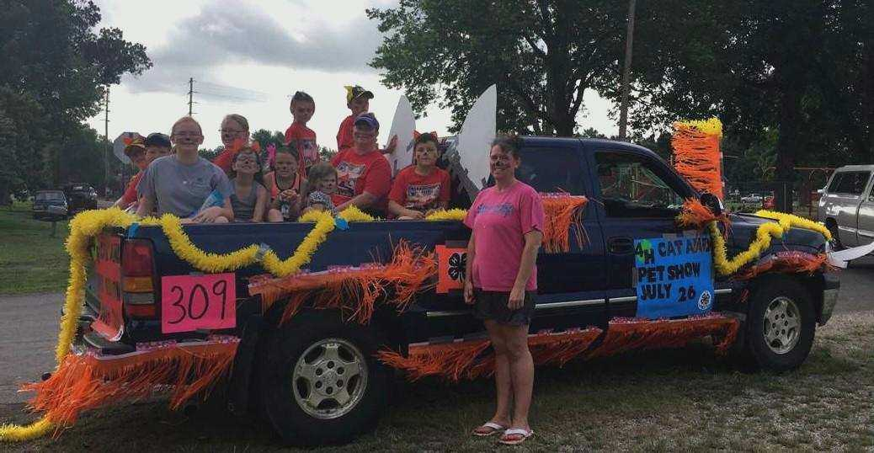
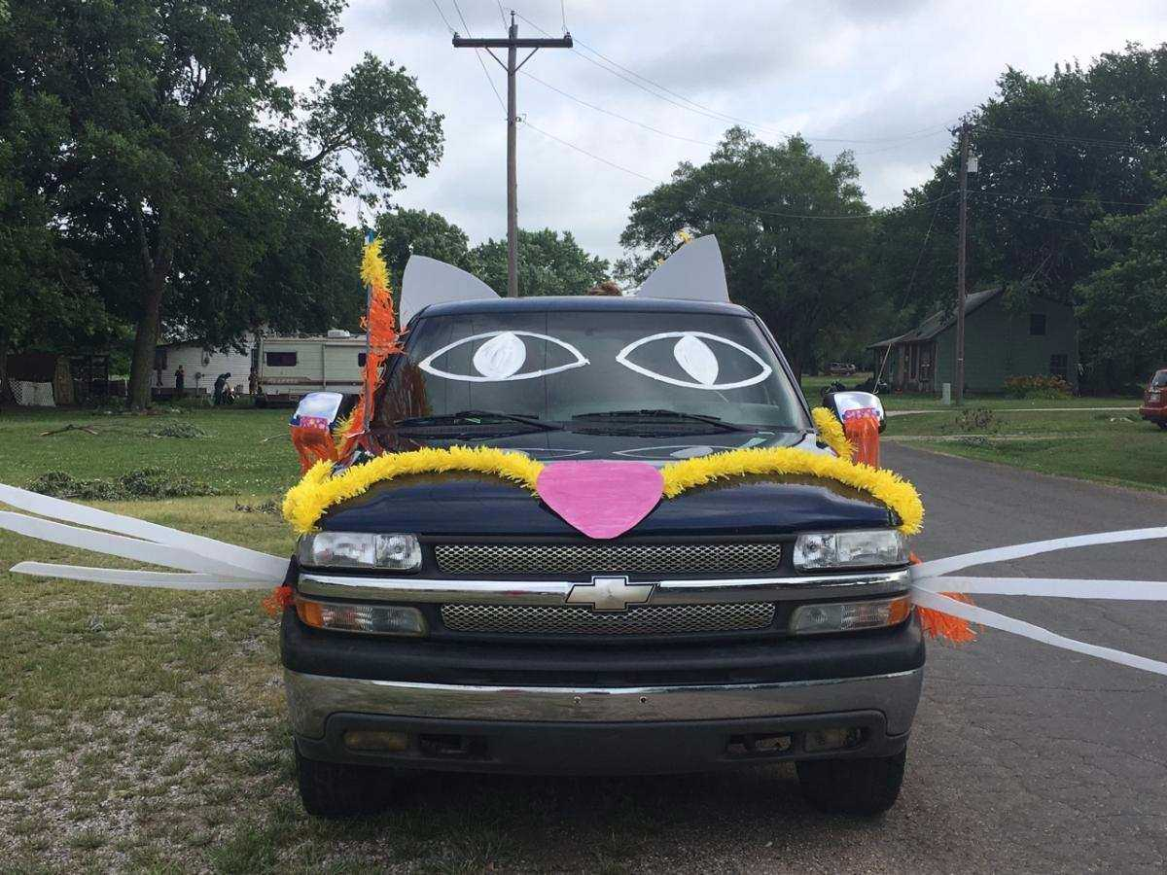

Morris County Fair Information
The dates of the Morris County Fair are
July 22nd through July 31st. An electronic version of the fair book can be found on our website at: http://www.flinthills.k-state.edu/4-h/morris-county/fair/. Below is a list of details to note about the 2017 fair.

*Fair Supplies are available in the Extension office – photo matte boards with bags, large food bags, food labels, clothing labels and entomology pins. Check with the Extension office if you need something as you are preparing entries for the fair!
*Check-in for 4-H and Open Class exhibits (except food, horticulture, and floriculture exhibits) and livestock entries will be held on Friday, July 28th from 5:00 p.m. to 8:00 p.m. Food, Horticulture, and Floriculture exhibits can be check in from 7:00 a.m. to 9:00 a.m. on Saturday, July 29th.

*A Family and Consumer Sciences Judging Contest will be held in conjunction with the
4-H Clothing and Fashion Revue Judging during the Morris County Fair on Tuesday, July 25th.

*Clothing Construction and Fashion Revue: Pre-entry forms have been mailed to 4-Hers enrolled in the clothing construction and clothing buymanship projects. These forms have also been posted to the Flint Hills District website at the following link: http://www.flinthills.k-state.edu/4-h/morris-county/fair/. Also posted on the website, are modeling tips. This can be a great resource to 4-Hers as they prepare their entries for the fair!
*The Talent Showcase is open to all 4-Hers to participate. It is held in conjunction with the 4-H Fashion Revue on Tuesday, July 25th at 7:00 p.m. at the Council Grove High School Auditorium. Examples of entries can include vocal solos, dance routines, group ensembles, readings, or dramatics. The event is open to all Morris County 4-Hers. Youth do not need to be enrolled in the performing arts project to participate. The entry form is attached to this newsletter.

*Space Tech Forms: The 2017 exhibit forms that are required to accompany space tech exhibits at the fair have been posted to the Flint Hills District at the following link: http://www.flinthills.k-state.edu/4-h/morris-county/fair/. Remember, notebooks, display boards, and posters do not need additional exhibit information; no manila envelope is required for these exhibits.

*A photography judging contest will be held Sunday, July 30th, from 10:00 a.m. to 11:30 a.m. in the fair building. The contest will be used to determine participants for the photography judging contest held at the Kansas State Fair.


Bucket Calf Costume Parade
You are invited to dress your bucket calf in a costume and be in our Bucket Calf Costume Parade. Can your calf wear pants, fairy wings, a cape, or a funny hat? Make it twice as fun and dress up with your calf. Please bring a short paragraph about you & some facts about your calf: His/her name, the funniest or greatest thing they have done. Why you picked the costume they are wearing. The Costume Parade will take place following Beef Showmanship on Saturday July 29th at 6pm.

Kansas State Fair
The 2017 Kansas State Fair will be held Friday, September 8th through Sunday, September 17th.

*Pre-Entries: In order to exhibit projects at the Kansas State Fair, 4-Hers must be 9 years old by January 1, 2017. Livestock entries must have met nomination deadlines. For other projects, 4-Hers must receive a purple ribbon at the county fair and there must be a class available at the State Fair. Even though exhibits may be eligible for the State Fair, they must be pre-entered in the Extension Office.

*Three visual arts exhibits will be selected at the county fair to represent Morris County at the State Fair. Even though these exhibits are selected at the county level, they still must be pre-entered. Visual arts entries are for display purposes only and will be given a participation ribbon; no premium money will be awarded.

Please note the following entry deadlines:
July 15: Kansas State Fair (Grand Drive) entries for beef, sheep, swine, and meat goats are due to the Kansas State Fair Office. These entries must have a county agent’s signature. Instructions for online registration can be found here:
http://www.kansasstatefair.com/p/exhibitors/livestock-competitions/377

August 1: Horse entries with fees are due to the Kansas State Fair Office. These entries must have a county agent’s signature.

August 10: All other 4-H State Fair pre-entries are due to the Extension Office. Demonstration and Fashion Revue entries must also be pre-entered and are due by August 10th.
Kansas State Fair
Encampment Building Reservations
4-Hers, adult leaders, and those working with 4-H exhibits at the Kansas State Fair can stay in the Encampment Building on the fairgrounds. Space is not available for children under the age of 7. The cost is $15 per person per night. Payment and reservations for bed space need to be made to the Extension Office by August 8th.

Advance Gate Tickets
for the Kansas State Fair
4-H families may order youth and adult admission tickets in advance through the Extension Office. Orders and payment need to be turned into the Extension Office by August 8th. 4-Hers exhibiting livestock, horses, or dogs can purchase parking lot hangtags. Additional information about hang tag and ticket prices will be available during the Morris County Fair and at a later date in the Extension Office.

**Those wishing to sign up for
State Fair Entries can do so at the
County Fair.**



Food Preservation Class
Come join us for a hands-on workshop to learn about safely pressure canning, water bath canning, dehydration and freezing your food harvest. Cost is $20 to attend. Lunch will be provided and each participant will take home their canned products. Registration and payment are due by June 30th with the class held on July 15th from 9am-4pm at the Simpson United Methodist Church in Alta Vista, KS. To sign up for class please contact the Extension Office. 620.767.5136

Morris County Conservation District’s 18th Annual Photo Contest
The Morris County Conservation District is sponsoring its 18th Annual Photography Competition. Cash awards will be given, and winning entries will be exhibited at the District’s Annual Meeting on January 27, 2018. Entries are due November 3, 2017 at the Morris County Conservation District Office.

Livestock Sweepstakes
Kansas 4-H Livestock Sweepstakes will be held August 19th-20th on the K State campus in Manhattan, KS. This is the corresponding date to previous years. The 4-H Livestock Sweepstakes event includes the state 4-H livestock judging contest, meat judging contest, livestock skillathon, and livestock quiz bowl. The members who will represent Kansas at the national 4-H contest for each of these events will be selected August 1st. All entries must be made through your local Extension Office. Any questions regarding member eligibility need to be inquired through the local extension office before the entry deadline. Rules and information may be found on the KSU Youth Livestock Program website. Website: www.youthlivestock.ksu.edu

2017 Kansas 4-H State Wheat Expo
The Kansas 4-H State Wheat Expo is a wheat fun day showcasing all things wheat. Join us for the annual event on Thursday, August 3rd from 9:00 a.m. – 3:00 p.m. at the Ford County Fair Building, 901 West Park, Dodge City, KS 67801. It is open to all 4-H family members, 4-H leaders and Extension staff. There will be eight contests open to youth members with cash prizes and ribbons awarded. There will be three tour options. There is a $6.00 per person registration cost. Registration is now open. Visit: http://www.kansas4-h.org/events/index.html. Pre-registration will be required by Monday, July 24, 11:59 p.m. to ensure an accurate meal count and tour divisions.

Kansas 4-H and FFA
Wheat Variety Plots
As wheat harvest approaches it is time to remind members to re-enroll or ask new members to enroll for the 2018 Kansas 4-H and FFA Wheat Variety Plot program. The program begins fall of 2017 and goes through September 2018. The enrollment form and program details are currently available. Visit: http://www.kansas4-h.org/events-activities/conferences-events/wheat/wheat-variety
plots/index.html. Members are asked to contact their local Extension Office by July 10 for information with enrollments due to the Northwest Area Extension Office by July 24, 2017. Cost for 2017-18 will be $35.00 to receive the five varieties of wheat. New participants will receive a free large plot sign, and five free individual variety signs. These will be distributed on Friday, September 8th at the 2017 Kansas State Fair.

North Central District Horse Show
The North Central District Horse Show will take place at Saline County Expo Center,
Ag Hall in Salina, KS on July 5, 2017. Check in will be from 7am-12pm. The show will begin at 9am.

Mark Your 2017 Calendars
July 3 & 4 – Extension Office Closed
July 6-8 – Tri County Fair
July 11 – Cat Meeting
July 15 – Food Preservation Class
July 18 – Cat Meeting
July 16-18 – Leadership Unlocked
July 22-31 – Morris County Fair
July 26 – Council/Ambassador Meeting
Aug 8 – State Fair Advance Tickets Order Form Due
September 8-17 – Kansas State Fair

Livestock Calendar
July 5 – North Central District Horse Show
July 7-8 – Dr. Bob Hines Swine Classic
July 29 – Bucket Calf Costume Parade
August 3 – Wheat Expo
August 19-20 – Livestock Sweepstakes

Extension Office Closed
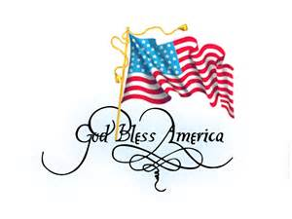
The Extension office will be closed on Monday, July 3rd and Tuesday, July 4th for the Independence Day holiday.

Morris County Conservation District’s 18th Annual Photo Contest

To recognize individuals who use photography to capture conservation images effectively and creatively, the Morris County Conservation District is sponsoring its 18th Annual Phototography Competition. Cash awards will be given, and winning entries will be exhibited at the District’s Annual Meeting on January 27, 2018.

The contest is open to amateur photographers (those who earn less than 80% of their income from photography) who are residents of or attend school in Morris County. Photos entered must have been taken in this calendar year in Morris County, and may be entered in the following categories:

*Conservation Practices – Photos of volunteers planting trees or of district personnel advising a farmer could be entered in the category. Shots of erosion, a pulluted stream or other conservation challenges are also appropriate.

*Opportunities in Conservation Education – Entries in this category might show a workshop for local teachers or a farmer learning about wetlands. This is also the place to enter your best photos of children taking part in conservation activities.

*Wildlife – In this category, you might show deer running through the woods or a bird nest in an urban neighborhood.

*Prarie Landscapes – Sunsets, pastures, city parks, and other impressive views are appropriate sibjects for this category.

*Youth Only – This category is designed for youths up to age 18. Photos may cover any of the above adult categories. All photos will be judges as one category.

Each participant may enter up to, but no more than, four photographs. The photographs will not be returned. They may be black and white or in color, and will be judged together. Photos should be no larger than 8 X 10 inches and no smaller than 5 X 7 inches. Photographs should be placed in an 8 X 10 picture page envelope and they should not be matted.

A 3 X 5 notecard containing the following information must be attached to the back of each photo: photographer’s name, address and phone number, and catgeory entered. Negatives need to be enclosed in a protective jacket attached to the back of the picture at time of entry or email a jpeg.

One First Place Photo: $25.00 Cash Award
One Second Place Photo: $15.00 Cash Award
One Third Place Photo: $7.50 Cash Award
Five Honorable Mentions: Brag Books

Entries are due November 3, 2017, at the Morris County Conservation District Office. For More information call Jo Bea Titus – Hutchinson at: 620-767-5111 Extension 101. Upon acceptance of Cash Awards, all rights and privilege of winning photos and negatives belong to the Morris County Conservation District. Further photos may be deemed Honarable Mention with apropriate awards given.

