

Discovery Days May 30-June 2

4-H Camp June 24-27
Sun | Mon | Tue | Wed | Thu | Fri | Sat
 |  |  |  | 1 | 2 | 3
4 | 5  4-H Council Mtg. followed by Ambassador Mtg.  @ 7p.m. | 6  County Cat Project Meeting  @ 6p.m. | 7 | 8 | 9 | 10
11 | 12 | 13 | 14   | 15 | 16 | 17  Touch-A-Truck  Event  @ Washunga Days
18   | 19 | 20 | 21   | 22 | 23  4-H Camp Counselor Training | 24  4-H Camp Begins today through  June 27
25 | 26 | 27  Last Day of  4-H Camp | 28 | 29 | 30  Morris County Fair Pre-Entry Deadline & Carcass Contest Entry Deadline  *Due by 5 p.m.*


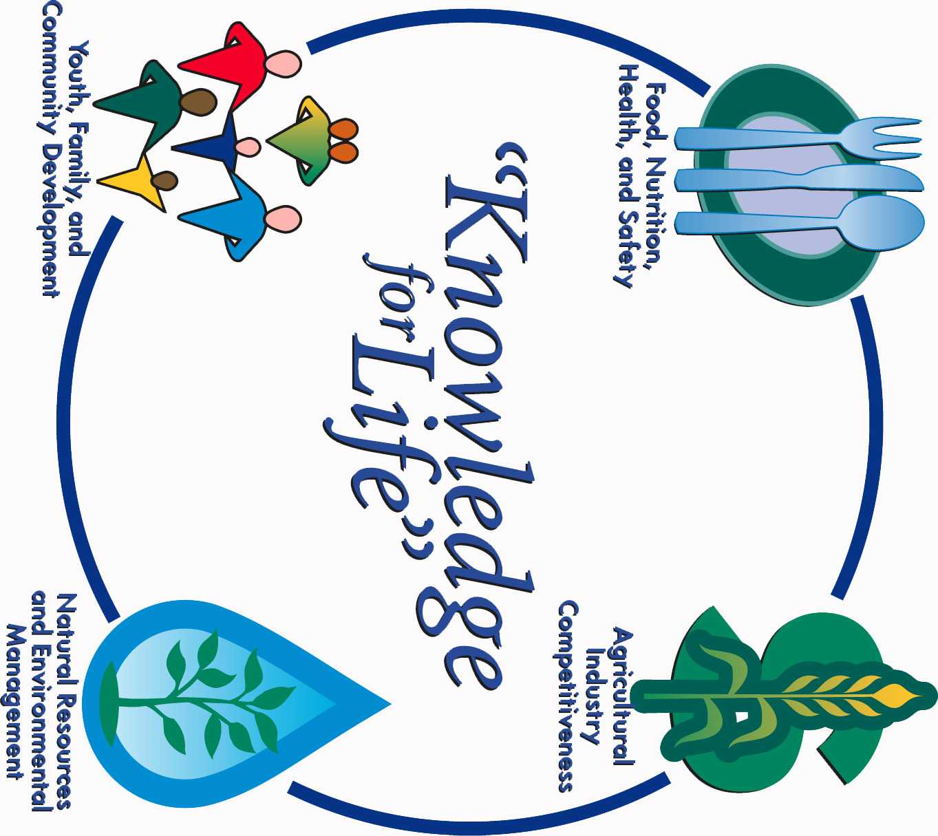


Morris County Extension Office
Courthouse – 501 West Main
Council Grove, KS 66846-1796
620-767-5136

JUNE 2017 4-H NEWSLETTER
Morris County
Flint Hills Extension District

Lori Bammerlin Shandi D. AndresAllicia Ochoa
Agent, Agriculture/4-H Agent, Family & Consumer Office Professional
Sciences/4-H

Kansas State University
Agricultural Experiment
Station & Cooperative
Extension Service
K-State County Extension
Councils, Extension Districts
& U.S. Department of
Agriculture Cooperating
All Educational programs and
Materials available without Discrimination on the basis
Of race, color, religion, national
Origin, sex age or disability

