March 2017

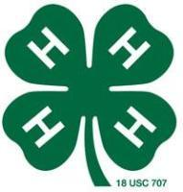


4-H Council Meeting
The next 4-H Council meeting will be held Monday, April 24th in the courthouse meeting room at 7:00 p.m.

4-H Ambassador Meeting
The Morris County 4-H Ambassadors will meet on Monday, April 24th in the courthouse meeting room following the 4-H Council meeting.

Citizenship in Action
Two Flint Hills District 4-Hers, Jamie Beck and Makenzie Downes, attended Citizenship in Action February 19-20 at the State Capitol in Topeka.

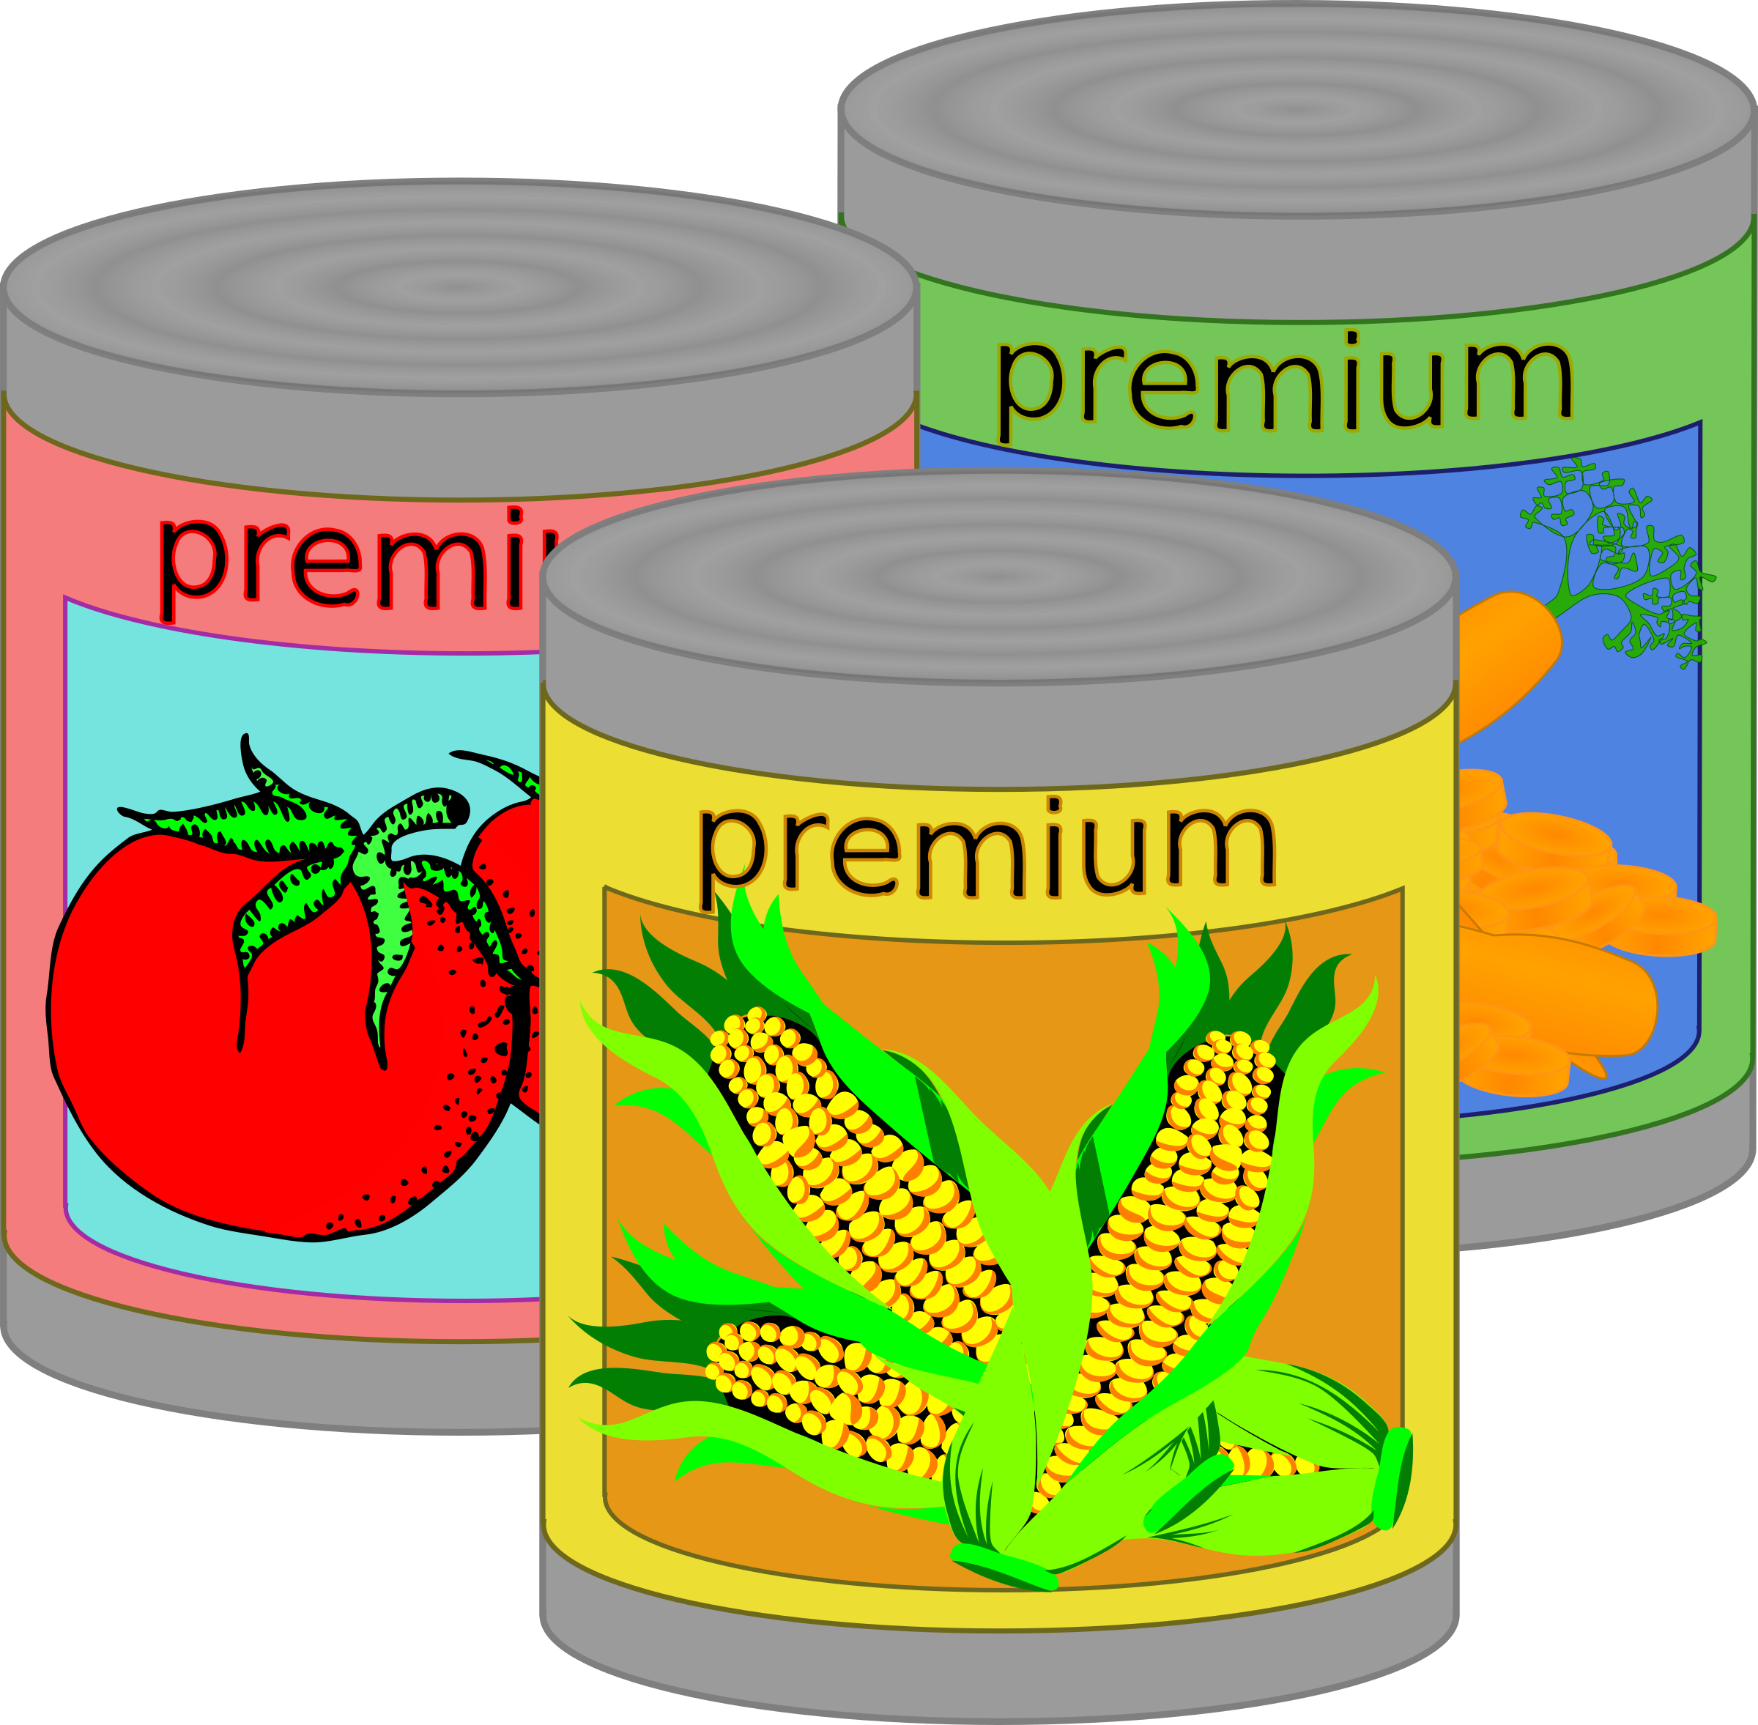

4-H Club Day
The Morris County 4-H Club Day will be held on Saturday, March 4th at the Council Grove Elementary School. Every family that had an entry will receive the schedule/booklet in the mail. It will also be posted on our website.
We will be setting up for 4-H Club Day on Friday, March 3rd at 5pm. We would appreciate anyone who is available to help.
REMINDERS:
Make sure you schedule your times
Make sure to be at CGES at 7:30 to get your time slots!
Schedule will be posted at 7:30


Club Day Cookie Plates
To show our appreciation to the teachers and staff for allowing us to use the Council Grove Elementary School for 4-H Club Day, each club is asked to bring a plate of cookies (2 dozen) and a signed thank you note from club members. Cookie plates and thank you notes can be dropped off in the teachers’ lounge on the morning of Club Day.

Stack up against hunger!
The Morris County 4-H Ambassadors are having a canned food drive at Club Days (March 4th). Bring canned items to help build the biggest pyramid possible! Items will be donated to Care and Share as well as the Main Street Pantry. Help us stack up against hunger!

Regional 4-H Club Day
Regional 4-H Club Day will be held on Saturday, March 18th at Madison High School. If you qualify for Regionals, please let the Extension Office know as soon as possible following County 4-H Club Day whether or not you are planning to exhibit at Madison. This will allow the Extension Office time to contact alternates, if necessary.

Morris County 4-H Foundation Incentive Awards
4-H clubs will receive $10 for each top blue awarded to their club or club member at 4-H Club Day. Clubs should also keep track of the activities they do to promote interest in joining 4-H. Some examples include recruitment booths at school activities or other public events and/or participation in parades. The club will earn $10 for each event that qualifies. The Morris County 4-H Foundation will review the Morris County 4-H Club Summary Report to select winning activities. If desired, clubs may attach a note suggesting which items they feel qualify or provide further explanation to judge their promotion.

Cloverbud Meeting
The next Cloverbud meeting will be held on Thursday, March 16th at 6:00 p.m. in the meeting room of the Morris County Courthouse.

Swine Project Meeting
County Project leader Robert Bacon will be taking a group to the Jr. Swine Producers Day on March 11. If interested in riding with the group please call the extension office.

Goat Project Meeting
County Project leader Charles Downes will be taking a group to the Jr. Goat Producers Day on March 25. If interested in riding with the group please call the extension office.


Lamb Selection Clinic
Saturday, March 4th from 1-4p.m. there will be a lamb selection clinic. It will be at the KSU Sheep and Meat Goat Center in Manhattan. You can get your registration forms in the Extension Office.

K-State Sheep
Producer Day
Saturday, March 4th is the K-State Sheep Producer Day held in Manhattan at the K- State Sheep and Goat Center. Registration is at 8:15 a.m. No pre-registration required. The cost is $15- for KSA members and $25 for non- members. Lunch will be provided. I have attached the flyer for this event, if you have any questions about this event contact the Extension Office.

Kansas Junior Meat Goat
Producer Day
The 5th biennial Junior Meat Goat Producer Day will be held on March 25, 2017 with registration at 8:45 a.m. Early registration is due March 3rd. More information is available in the Extension office or register online at: commerce.cashnet.com/KSUASIND.

Kansas Junior Swine Producer Day
March 11, 2017 in Weber Arena on the K-State campus will be the location for Kansas Junior Swine Producer Day. More information is available in the Extension office or register online at: commerce.cashnet.com/KSUASIND.

Kansas Leadership Center Trainings
(KLC)
The Kansas 4-H Foundation is pleased to present leadership training classes in partnership with the Kansas Leadership Center. If you are a 4-H parent, volunteer, alumni or agent, this training is for you! Join us for one or all of the classes below to build your leadership skills
Kansas Leadership Center staff will share the KLC core curriculum that equips people with the ability to make lasting change for the common good. KLC is different in the field of leadership development with its focus on leadership as an activity, not a role or position. KLC envisions more Kansans sharing responsibility for acting together in pursuit of the common good. Come learn how these principles can help move the work of Kansas 4-H forward. For more information visit:
https://kansas4hfoundation.org/klc/

World Food Prize
Kansas Youth Institute (KYI)
KSU college of Agriculture is hosting the 4th annual KYI on Thursday, April 20th. The institute is an opportunity for high school students to join the conversation about feeding the world. Students and their teachers are invited to KSU to interact with agricultural experts and distinguished guests, discuss global food security issues, and participate in experiential learning sessions in the College of Agriculture. For more information or any questions contact: Alyson Lister at 785-532-5121 or alister@ksu.edu

4 H Photography Workshop
Photography Workshop “Ingredients for Photo Success” will be held on Sunday, March 19th in Auburn KS at the Auburn Community Center. The main workshops are from 1-4 p.m. You will need to bring your digital camera, memory cards for lots of photos, fresh battery, battery charger, and tripod(optional) Classes are designed to be hands on for 45 minutes each. Registration fee is $5 per person, which includes three workshop sessions. There is a $2 fee for the contest, which covers cost of materials and photocopying. Registration is due by March 11th. No refunds. Registration forms can be picked up in Extension Office.

4H College and Career Day
This year’s 4H College and Career Day will be held at Dodge City Community College in Dodge City, KS. It will be held on April 20th with registration starting at 11:30 a.m. College and Career Day is focused on the youth audience from 6th-12th grade, but any family members are welcome to attend. Registration is due March 31st. Email your Name, County, Grade, and Phone number to Lexi Kiniston, Ford County 4H Youth Development Agent, at: lkiniston@ksu.edu
For any questions call: 620.227.4542

Morris County 4-H
Foundation Scholarships
Once again the Morris County 4-H Foundation is offering scholarships to present or past Morris County 4-H members. Also, please note that students can apply and receive the scholarship twice. Applications are available in the Extension Office, on our website, or from your school counselor. The application deadline is May 1st.
Foods and Nutrition Project Meeting
There will be a countywide foods project meeting on February 28th at the Fair Ground Building at 6p.m. At this meeting 4-H’ers will prepare Tater Tot Casserole or Cavatini. You will be browning and assembling the casseroles at the meeting, and then each 4-H’er will be taking theirs home to bake. Cost will be $3 per 4-H’er. You will also be responsible for bringing 1lb of thawed ground beef and a 9x13 pan for your casserole. If you have any questions, please contact Mary Ellerman at mary_ellerman@yahoo.com.
Please RSVP to the Extension Office (620.767.5136) by February 22nd.

Morris County Fair
The Morris County Fair will be July 22-July 31. The schedule will remain similar as last year, with the exception of the dog show being held on Saturday, July 22nd at 9:00 a.m. Hand/Pet Show will be Wednesday, July 26th at 10 a.m. Cat Show will follow hand/pet show at 10:30 a.m.
Our fair secretary is Laci Thibodeaux. She can be contacted by email at laci.lou.25@gmail.com, by phone at 620.877.7253, or by mailing address is 1209 G Ave, Dwight.

Morris County 4H Foundation
Anniversary Celebration
Celebration of the 40th anniversary of the Morris County 4-H Foundation sponsoring activities of 4-H club members is planned Friday evening, April 7, at 7 o’clock, in the fairgrounds community building.
All persons interested in the Morris County 4-H program have been extended an invitation to attend the evening supper program.
Top 4-H Club Day numbers will be presented, along with a review of assistance the foundation has provided 4-H members through the years.
Supported strictly by member donations, the Morris County 4-H Foundation has provided help for more than 2,000 4-H members to participate in special 4-H activities.
A total of $37,225 has been given in 103 Morris County 4-H Foundation Scholarships to 4-H club members.
Anniversary supper celebration reservations of $11 per meal, with checks payable to the Morris County 4-H Foundation, should be mailed by March 29th to Connie Burton, 1867 C Avenue, White City KS 66872.
Information is available by emailing gcon10@hotmail.com.

Discovery Days
Discovery Days will be held May 30 - June 2, 2017 on the Kansas State University campus in Manhattan. This mini college experience is designed for youth who are 13-18 years of age as of January 1, 2017. The theme this year is “Make A Splash.” Participants will have the opportunity to select classes, attend social functions, and be a part of community service opportunities.

Walk Kansas for Kids

The Council Grove and Prairie Heights Elementary Schools will be participating in the Walk Kansas for Kids program, March 19th – May 13th. The goals of the program are to encourage physical activity and the importance of choosing a healthy lifestyle. During the six weeks, youth will complete a weekly activity log, receive a weekly newsletter with healthy tips, and earn incentives. Students will also have the opportunity to engage in weekly walking activities with other students participating in the program. Please see Ms. Reddick, school nurse, the Morris County Health Department, or the Extension Office for more details and registration information.

Gary Fuller Spring Classic
Spring Classic is May 6th-7th at the Lyon County Fairgrounds in Emporia KS. Pre-entries are due April 28th: $15 per head. After April 28th: $25 per head. Schedule, guidelines, and registration form are located in the Extension Office.

2017 Shawnee County Invitational
4H Dog Show
4H Dog Show is on Saturday, April 1st in Ag Hall at the Kansas Expocentre. Show starts at 9 a.m. Doors open at 7:30 a.m. with check-in to follow starting at 8 a.m. Information and registration form can be found in Extension Office.

Wild Bill Beef Shoot-out
This year’s Beef Shoot-out is held on Saturday, April 1st at the CKFF Fairgrounds in Abilene KS. Online entries can be found at:
http://tinyurl.com/2017WBbeefshow
Extension Office also has information and registration forms.

Harvey County 4-H
Spring Beef Show
2017 Harvey County Spring Beef Show will be on Saturday, March 25th. It will be located at the fairgrounds in Newton, KS. It is open to all Kansas 4-H and FFA members age 7 as of January 1, 2017, and not over age 19 as of January 1, 2017. Entry fee is $10 per animal for out of county. All entries are due March 20th. All late entries and day of show entries, the fee will double. Registration papers are required. Barn opens at 7a.m. on the day of the show. Heifers must be checked in by 9a.m. Market animals will weigh in between 8:30 and 9:30 a.m. Breed qualifications and classes will be based on state show rules. For more information and registration form contact Extension Office (620.767.5136)

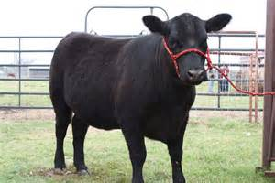
Beef Weigh-In
Beef Weigh-In will be held on April 8th. From 8a.m. to 9a.m. at Derek Schrader’s (16875 K177, Alta Vista).

Small Animal Weigh-In
April 30th from 4p.m.-5:30p.m. will be small Animal Weigh-In at the Fairgrounds. Small animals include (sheep, goats, swine, and bucket calf) Tagging for hogs will be the same as last year. (You may pick up tags in the Extension office, tag the hog, then send a picture of that animal showing the tag in ear by email to bammerlin@ksu.edu)

Southwest Livestock
Judging Contest
Saturday, March 4th at Seward County Community College in Liberal KS, contest starting at 9 a.m. with registration from 8-8:30 a.m. Pre- registration is preferred by Wednesday, March 1st. There is a $5 fee per participant. Divisions are- Junior: 7th grade and younger Senior: 8th grade and older. Registration and more information are located at the Extension Office.

Cowley County Livestock Show
Beef Classic -Saturday April 29th, at the Winfield Fairgrounds, Winfield KS.
Sheep & Goat – Saturday, May 27th
Swine- Saturday May 27th – Sunday May 28th. Registration forms and more information are available in the Cowley County website: www.cowley.ksu.edu

Shawnee County State Wide
4-H & FFA Livestock Show
Event will be held at the Jackson County Fairgrounds in Holton KS on Saturday May 6th.This show is open to all 4-H’ers and FFA members who are between the ages of 7-18 as of January 1st. Exhibitors may only show beef, sheep, or meat goats that have been owned and tagged by May 6th. For more information and registration forms see website:
http://www.shawnee.ksu.edu/4-h/event-fliers
*flier and registration located under “Livestock Shows”*
There are also registration forms in Extension Office.

K-State Animal Sciences
Leadership Academy
Applications are now being accepted for the 2017 K-State Animal Sciences Leadership Academy. This intensive four-day educational experience is designed to enhance the leadership skills and animal science knowledge of students in 9th through 12th grades. The academy is being hosted by the K-State Department of Animal Sciences and Industry and sponsored by the Livestock and Meat Industry Council. There will be two sessions offered this year and are scheduled for June 14-17 in Manhattan. Additional information and applications are available in the Extension Office. The application deadline is April 1st.

Livestock Judging Camps
The KSU “Champions” Livestock Judging Camp is a three day, intense judging camp designed for 4-H and FFA members, ages 14-18, who are seriously interested in enhancing their livestock judging and oral communication skills. Prior livestock judging experience is necessary for this camp. Workouts will be conducted similar to those at a collegiate level. Mini camps will be conducted in June. Each camp will be limited to 35 students and will be accepted on a “first come-first serve” basis. The following dates are set for the 2016 camps. June 7-9, June 12-14, June 16-18. Registration forms and more information are available in the Extension Office. Registration and payment is due by May 22.

Kansas 4-H Sewing Camp

Teen Counselors (16 and older) and Adult Volunteer Leaders are needed to assist with this year sewing camp. It is on May 30- June 2 at the Manhattan K State Campus. Applications can be picked up in the Extension Office and are due by April 1st. If you have any questions please contact Mary Bernhardt at: mary_bernhardt@cox.net

Livestock Calendar
March 4 – Lamb Selection Clinic
March 4 – Sheep Producer Day
March 4 – Southwest Livestock Judging Contest
March 11 – Junior Swine Producer Day
March 25 – Junior Meat Goat Producer Day
March 25 – Harvey County Spring Beef Show
April 1 – Wild Bill Beef Shoot-out
April 8 – Beef Weigh-In
April 29 – Beef Classic
April 30 – Small Animal Weigh-In
May 6 – Shawnee County State Wide Livestock Show
May 6-7 – Gary Fuller Spring Classic
May 27 – Sheep, Goat, and Swine Classic
June 7-9 – Livestock Judging Camp
June 12-14 – Livestock Judging Camp
June 16-18 – Livestock Judging Camp

Mark Your 2017 Calendars
March 3 – Set up for Club Days
March 4 – Club Days
March 16 – Cloverbud Meeting
March 18 – Regional Club Days
March 19 – Photography Workshop
March 19-May 13 – Walk KS for Kids
April 1 – Shawnee County Invitational Dog Show
April 7 – 4H Foundation Anniversary Celebration
April 20 – World Food Prize KS Youth Institute
May 30 – June 2 – Discovery Days
May 30 – June 2 – Kansas 4 H Sewing Camp
June 14-17 – Animal Sciences Leadership Academy
June 24-27 – Sunny Hills 4-H Camp
July 22-July 31- Morris County Fair
Sept. 8-17 – Kansas State Fair
Sept. 29 - Oct.1 - KJLS

