

Sun | Mon | Tue | Wed | Thu | Fri | Sat
 | 1  Fair T - Shirt Orders Due  Foundation Scholarships Due  Horse ID’s Due  Project Add/Drop Deadline | 2 | 3 | 4 | 5 | 6
7 | 8 | 9 | 10 | 11 | 12 | 13
14   | 15  4-H Camp Registrations and Counselor Applications Due  Konley Harding Scholarship Applications Due | 16 | 17 | 18 | 19 | 20
21 | 22 | 23 | 24 | 25 | 26 | 27
28 | 29  Extension Office Closed for  Memorial Day   | 30  Discovery Days and  KS Sewing Camp  May 30-June 2 | 31  Babysitting Clinic  9am-12pm


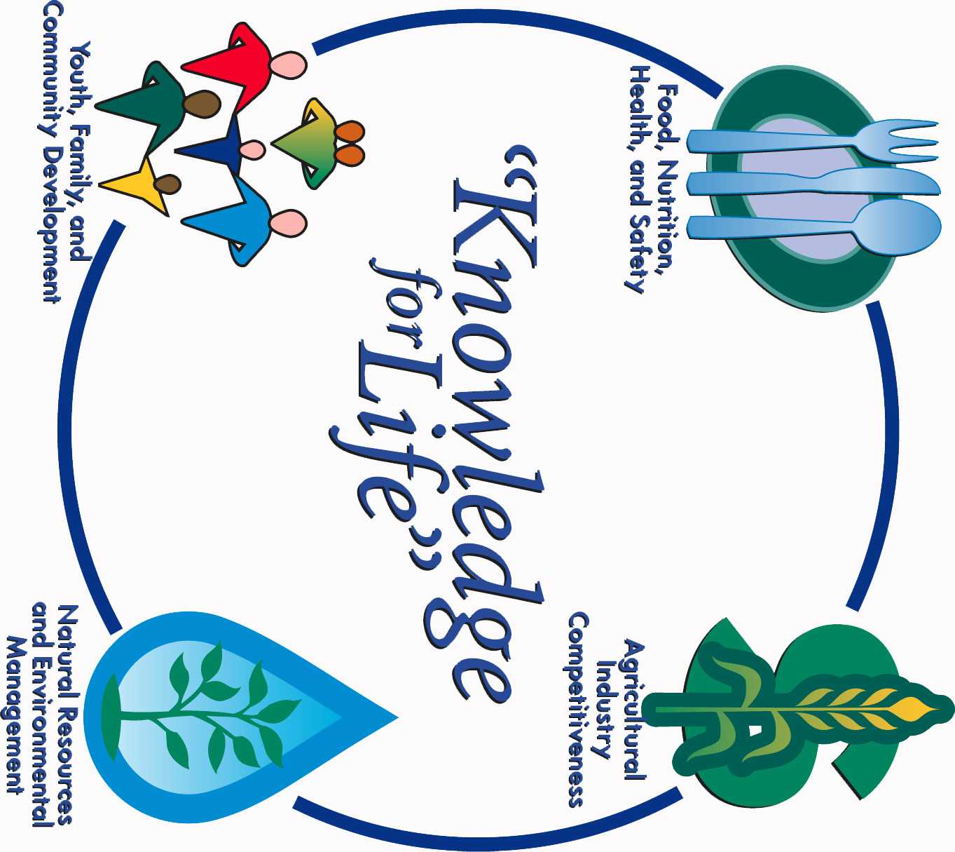


Morris County Extension Office
Courthouse – 501 West Main
Council Grove, KS 66846-1796
620-767-5136

MAY 2017 4-H NEWSLETTER
Morris County
Flint Hills Extension District

Lori Bammerlin Shandi AndresAllicia Ochoa
Agent, Agriculture/4-H Agent, Family & Consumer Office Professional
Sciences/4-H

Kansas State University
Agricultural Experiment
Station & Cooperative
Extension Service
K-State County Extension
Councils, Extension Districts
& U.S. Department of
Agriculture Cooperating
All Educational programs and
Materials available without Discrimination on the basis
Of race, color, religion, national
Origin, sex age or disability

