May 2017

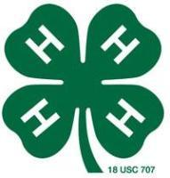


4-H Council Meeting
The next 4-H Council meeting will be held Monday, June 5th in the courthouse meeting room at 7:00 p.m.

4-H Ambassador Meeting
The Morris County 4-H Ambassadors will meet on Monday, June 5th in the courthouse meeting room following the 4-H Council meeting.

Cloverbud Meeting
The next Cloverbud Meeting will be on May 4th from 6pm-8pm in the Courthouse Meeting Room.
Cat Meeting
A Cat Meeting is scheduled for Tuesday, June 6th at 6pm in the Courthouse Meeting Room. Topics for discussion will be: cat show details and begin designing the parade float.

Add/Drop Deadline
The deadline to add or drop a project is Monday, May 1st. Please make any changes you want to projects on 4-H Online before midnight. If you need assistance from our office, please contact us before the office closes at 5:00 pm.

Horse ID Papers Deadline
Horse ID papers are due in Extension Office on Monday, May 1st. Please bring your ID papers in before Office closes at 5p.m.

4-H Foundation Banquet
A big thank you goes to the 4-Hers who presented at the Morris County 4-H Foundation Banquet. Thanks also goes to Michelle Schrader and the 4-H Ambassadors who h. We appreciate your hard work. You all did a great job!!

Morris County 4-H
Foundation Scholarships
Once again the Morris County 4-H Foundation is offering scholarships to present or past Morris County 4-H members. Also, please note that students can apply and receive the scholarship twice. Applications are available in the Extension Office, on our website, or from your school counselor. The application deadline is May 1st.

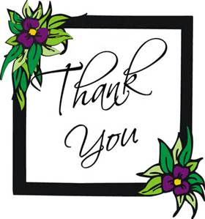
Remember to Send
Thank You Notes!
Please remember to send a thank you note to the Morris County 4-H Foundation if you are attending 4-H Camp or Discovery Days. The foundation is providing much support for Morris County 4-Hers to attend these summer activities!
Thank you notes can be dropped off or mailed to the Extension Office!

Welcome Shandi!
We would like to welcome Shandi Andres to our district’s team as our new Family and Consumer Science Agent in the Council Grove office. Shandi earned her bachelor’s degree in Human Ecology with an emphasis in Family and Consumer Sciences Education and a Masters in Family Studies and Human Services, both from Kansas State University. Shandi previously served as the Family and Consumer Sciences teacher for Paola High School in Paola, KS. Stop by to welcome her and say hello!

4-Hers at Hand Pet Meeting

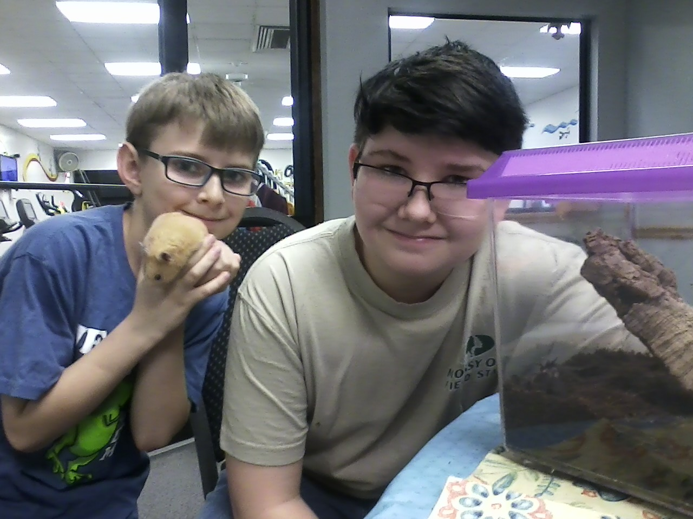

Morris County 4-Hers Vaughn and Isiah Thibodeaux at the hand pet meeting with their pets: Terri the Tarantula and Charles the Hamster.

Morris County Fair T-Shirts
The Extension Office is currently taking orders for Morris County Fair T-shirts. T –shirt orders are due May 1st. The shirts will be Red (matching the fair book) with design for the theme “Barn in the USA” Youth small through Adult XL are $8.75 each. Adult 2XL - $11.75, Adult 3XL through Adult 5XL are $12.25.
**4-Hers that plan to exhibit and show at the fair will be provided a fair shirt. Please order through your 4-H club. The shirt will be required to wear during livestock shows and other judging events.


Konley Harding
Memorial Scholarship
Applications are now being accepted for a $1000 academic scholarship in memory of Konley Harding. Applicants must be a current or former 4-H member and a graduating high school senior planning to pursue higher education at a four year college, community college, or vocational technical school. Preference will be given to applicants seeking an agricultural related field of study. Applications are due May 15th and are available in the Extension Office or on the website at www.flinthills.ksu.edu.

Kansas State Fair 2017
Summer Reading Challenge
The Kansas State Fair wants to encourage students to read over the summer and learn more about agriculture. Simply read eight qualifying books this summer and record them. Books read aloud by an adult can also be counted. Mail your journal to the Kansas State Fair by August 15th to receive your KSF reading fun pack which includes a special ribbon & fun Kansas agriculture information. Your name will also be put into a drawing for a free Kids Club ticket package to attend the 2017 Kansas State Fair. Reading Journals can be found in Extension Office.

Range Youth Camp
The Kansas Section of the Society for Range Management will once again be sponsoring the Kansas Range Youth Camp this year from June 20-23. This camp has been held for over 55 years, and the purpose of the camp is to educate youth about what rangelands are, why they are important, and how best to manage these lands sustainably. The camp is held at Camp Mennoscah in Kingman County, and high school students that are currently freshmen, sophmores, or juniors are eligible to attend. Any student that is interested in livestock, wildlife management, soils, native plants, or natural resources is sure to learn something interesting and have a fun time doing it. There is a lot of time spent outdoors doing ‘hands-on’ activities, and several field trips will allow students to see first- hand some local operations. Registration is going on right now and ends May 15th. The cost of camp is $250, but the Morris County Conservation District will sponsor a local student. Interested students are encouraged to contact the conservation district to inquire about funding at 620-767-5111 – Ext. 101. More information as well as forms can be found on the Kansas SRM website: http://rangelands.org/kansas/kansas-range-youth-camp/. The camp coordinator, Amber Johnson, can be contacted at aaj1@usa.com or 620-644-8293 with questions.

Sunny Hills 4-H Camp

The 2017 camp dates are June 24-27 at Rock Springs Ranch 4-H Center. Camp is open to 4-Hers who have completed 3rd through 7th grade. Registration forms were attached to the April newsletter and are available on our website at flinthills.ksu.edu. The Morris County 4-H Foundation will provide $145 of support. As a result, the camp registration cost for a Morris County 4-Her is just $55 (plus $5.50 for a shirt if you would like one) instead of the full registration fee of $200. Registration forms and payment are due in the Extension Office by May 15th.

Leadership Unlocked
This year’s Leadership Unlocked will be held on July 16th-18th at the Rock Springs 4-H Center. This leadership adventure is open to all Kansas High School youth who will be a sophomore of junior beginning the fall of 2017. Registration deadline is June 1st. To register you can go online at: kansas4hfoundation.org/leadership-unlocked/
Camp fee is $275.

Be a Better Babysitter
The Flint Hills Extension District and the Morris County Health Department are sponsoring a Babysitting Clinic on Wednesday, May 31st for youth 11-15 years of age. The clinic will be held in the Courthouse Meeting Room in Council Grove from 9 a.m. to 12 p.m. Participants will have the opportunity to learn about the responsibilities of babysitting, child care duties, how to prevent injuries, and behavior management. The cost to attend is $15 and will include a first aid kit and handouts. To register, please submit your name, address, phone number, and check payable to the Morris County Health Department. Registration is due by May 26th. Information can be mailed or dropped off at the Health Department, which is located at 221 Hockaday, Council Grove, KS 66846. For questions, contact the Extension Office at 620.767.5136.

Geology Field Trip
The State 4-H Geology Field Trip will be held on June 9-11 in Tecumseh, KS. You will learn more about the geology project, collect specimens, and participate in quiz bowls and judging contests. Headquarters for the trip will be at the Shawnee Heights Middle School. The trip will cost $12/person and registration will close Sunday, May 21st. To register please visit: www.kansas4-h.org/events/index.html

Touch-A-Truck
Morris County Farm Bureau is looking for volunteers for their Touch-A-Truck event Saturday, June 17, 2017! The event will be made up of interactive booths made up of farm equipment, first responders & Ag educational activities. Volunteers will be in charge of helping participants in and out of equipment, helping facilitate an agricultural quiz and checking in the participants in at the gate.

This event will happen during the 2017 Washunga Days and will be held tentatively at the CG Baseball field. Morris County Farm Bureau would really appreciate any help we can get to hold this event! We believe this would be a good event for 4-Hers and FFA members to earn community service and to teach their peers more about agriculture in Morris County and even across the state.

There are two, two hour shifts. Shift times are: 12pm-2pm or 2pm-4pm. Volunteers are very welcome to work all four hours, if they please.

To sign up, call Mindy Andres (785-466-6323) or call the Flint Hills District Extension office (620-767-5136.)

Kansas Youth Livestock
State Nomination
The 2017 Kansas youth livestock state nomination season has begun! Youth who plan to show livestock projects in the Kansas State Fair Grand Drive (youth 4-H/FFA livestock show) or Kansas Junior Livestock Show (KJLS) must first state nominate their market animals and commercial females in order for them to be eligible for either show. Exhibiting at one or both state shows is a two- step process. The first step is nomination, which goes through K-State, and includes submitting paperwork, DNA for your animals, and a nomination fee. The second step is actually entering the show in which you would like to participate by going directly through the State Fair or KJLS.
This is a reminder that the market beef nomination deadline is approaching. All market beef nominations are due by May 1, 2017.
Nominations for swine, sheep, meat goats, and commercial heifers, are due June 15, 2017.This is a postmark deadline, but families are highly encouraged to get their nominations mailed early (via certified mail) to avoid missing the deadline. All nominations must also be submitted on the updated 2017 forms, or they will not be accepted. This year, the forms are fillable PDF documents, so you will be able to type your information into the fields and select a breed, etc. from a drop-down menu. If you prefer to fill out your paperwork by hand, you may print the forms and do that as well. All forms still require original signatures from exhibitors, a parent/guardian, and an extension agent for 4-H members or FFA advisor for FFA members.
K State Horse Judging Camp
The K State Horse Judging Team will host two camps this summer. A beginner’s day camp will be held on June 6th in Weber Hall. Registration is limited to the first 30 students and is $40 per person. The deadline to register is May 12th. The advanced camp will be held June7-8 in Weber Hall. Registration is $120 per participant and is due by May 12th. More information about either camp may be found under “Judging Camps” on the KSU Youth Livestock Website.
Website: www.youthlivestock.ksu.edu

Summer Food Program
This summer the Summer Food Program will be offered in both Council Grove and White City. The program will be available in Council Grove Monday-Friday June 5-July 14 at the Council Grove Elementary School. Food service in White City will take place on Tuesdays and Thursdays June 5-July 14 at White City School. There will be no service provided on July 4th. Food service begins at 12:00pm and ends at 12:30pm. Both locations will have activities provided from 12:30pm-1:00pm. This program is free to all children, 1-18 years of age. Adult meals are free to those adults accompanying a child to the program. Adults are welcome and encouraged to participate with their children. You will not need to complete any applications or meet any income requirements to enjoy this free meal program. In Council Grove transportation will be provided in cooperation with Morris County Transportation. Stops are available at Council Grove Library and Council Grove High School. Pick up is at 11:45am at Council Grove Library and 11:50am at Council Grove High School. Drop off at each location will follow the end of the program at 1, Monday-Friday.

***June 12th and July 10th are available if a 4-H group would like to lead the program for the day. If you are interested, please contact Shandi at the Extension Office (sdandres@ksu.edu or 620-767-5136). The Extension Office will be helping to lead the activities for youth on June 19th and July 3rd. We are looking for older 4-Hers to serve as leaders and lead a small group of youth during the activities. The Extension Office will provide all of the necessary supplies. Youth leaders will be able to eat lunch at 12 p.m. before helping lead activities from approximately 12:30 p.m. to 1:30 p.m. Please contact Shandi at sdandres@ksu.edu or 620-767-5136 if you are interested and available to serve in this leadership role on June 12th or July 3rd. This is another great opportunity for your 4-H record book!

Leavenworth County Small
Livestock Spring Show
This year Leavenworth County Small Livestock Spring Show will be on Saturday, May 20th. Pre- registration is due May 1st. The show will be held at Leavenworth County Fairgrounds in Tonganoxie KS. More information can be found in Extension Office.

Ellis County Spring Horse Show
This year’s Spring Horse Show will be held on June 4th at the Ellis County Fairgrounds. Entries open from 8am-9am with the show starting at 9:30am. Rules and registration are available in Extension Office.

Cowley County Spring Sheep
And Meat Goat Show
Sheep & Meat Goat – Saturday, May 27, pre-entries May 19. Registration forms and more information are available in the Extension Office.
National Raise Your Hand Campaign
The national Raise Your Hand campaign will provide an easy way for proud Kansas 4-H alumni to reconnect with the national and state 4-H program in new and exciting ways.

Kansas is committed to connecting with as many of the state’s estimated 200,000 4-H alumni as possible during the campaign. Only in Kansas will the generous partner, Stanion Wholesale Electric, Co., donate $2 for each “hand raised” who registers (up to $10,000). In addition, Kansas will be competing for a $20,000 1st place prize through the national registration challenge – that means you can help Kansas raise up to $30,000 by registering! The Raise Your Hand campaign runs March 1 – June 30, 2017.

Raising your hand is as easy as 1, 2, 3:
1. Raise Your Hand: Go to www.ks4h.org to show your pride as a Kansas 4-H alum.
- Compete for Your State: Raising your hand is a vote towards a $20,000, $10,000 or $5,000 award for the states with the most alumni hands raised, as well a $2 match from Stanion Wholesale Electric, Co.
- Pay It Forward: Tweet, post and share your #4HGrown support and tag fellow alumni asking them to raise their hands for their state at www.ks4h.org.

2017 Fair Sponsors Needed
There are a few awards still needing sponsors. If interested in sponsoring please contact Laci, the Fairboard secretary
Those needing sponsors are:
Sheep
Champion rate of gain market lamb
Supreme breeding ewe

Swine
Supreme breeding gilt
Reserve breeding gilt

Dairy cattle
Reserve Champion dairy showman

Market goats
Champion senior showman
Reserve Champion senior showman
Champion intermediate showman
Reserve Champion intermediate showman
Reserve Champion junior showman

Horse
Hi-point timed event-intermediate

Carcass
Champion hog carcass
Reserve Champion hog carcass

Forestry
Champion for each division (beginning a&b., intermediate a&b, senior a&b, advanced a&b)

2017 Morris County Fair
The dates for the 2017 Morris County Fair are set for July 22nd – July 31st. The theme for the 2017 fair will be, Barn in the USA. Below is the fair schedule:

SATURDAY – July 22nd
9:00 a.m. – Dog Show

TUESDAY – July 25th
1:00 p.m. – Clothing and Fashion Revue Judging
1:00 p.m.-3:00 p.m. – FCS Judging Contest
7:00 p.m. – Fashion Revue and Talent Showcase, Council Grove High School

WEDNESDAY – July 26th
10:00 a.m. – Cat Show and Hand Pet Show
6:00 p.m. – Fair Cleanup and Setup (Building and Livestock Areas)
7:00-8:00 p.m. – 4-H and Open Class Entries Accepted (Building Exhibits Only)

THURSDAY – July 27th
8:30 a.m. – 4-H and Open Horse Show

FRIDAY – July 28th
5:00-8:00 p.m. – Check-in 4-H & Open Class Exhibits (all non-perishable & all livestock entries)

SATURDAY – July 29th
7:00-9:00 a.m. – Check in 4-H and Open Class Entries (food, horticulture, floriculture items only)
9:30 a.m. – Swine Show (Showmanship followed by Pee-Wee Showmanship)
12:30 p.m. – Judging of 4-H and Open Class Foods Exhibits
12:30 p.m. – Judging of 4-H and Open Class Floriculture, Horticulture, and Field Crop Exhibits
12:30 p.m. – Judging of 4-H Fiber Arts Exhibits
1:00 p.m. – Poultry Show followed by Rabbit Show
2:00 p.m. – Judging of Banners, Duct Tape, and Home Environment Exhibits
2:00 p.m. – Judging of 4-H Arts and Crafts, Self-Determined, and Space Tech Exhibits
2:00 p.m. – Judging of Notebooks, Club Record Books, and Miscellaneous Exhibits
2:00 p.m. – Judging of Open Class Family and Consumer Sciences Exhibits
3:00 p.m. – Dairy Cattle Show followed by Dairy Goat Show
5:00 p.m. – 4-H Food Auction
5:30 p.m. – Root Beer Floats sponsored by Farmers and Drovers Bank
6:00 p.m. – Beef Show

SUNDAY – July 30th
10:00 a.m. – 11:30 a.m. – Photography Judging Contest
12:00 p.m. – Judging of Photography
1:00 p.m. – Judging of Shooting Sports, Wildlife, Woodworking, Electricity, Entomology, Forestry, and Geology Exhibits
2:00 p.m. – Shooting Sports (Shoot Out)
3:30 p.m. – Morris County Farm Bureau Activity
5:00 p.m. – Sheep Show followed by Meat Goat Show

MONDAY – July 31st
9:00 a.m. – Round Robin Showmanship
11:00 a.m. – Pictures of Saturday Afternoon and Sunday Winners
12:00 p.m. – Livestock Judging Contest
2:45 p.m. – County-wide 4-H Group Picture
3:00 p.m. – Barnyard Olympics
4:00 p.m. – Fairgrounds Clean Up
6:00 p.m. – Buyer Appreciation Meal (Last year’s livestock buyers will receive a free meal ticket)
7:00 p.m. – Awards Presentation
7:30 p.m. – Livestock Sale (Cookie Jars will be auctioned at this time)
7:30 p.m. – Release of All Exhibits

Morris County Fair Carcass Contest
Designation Deadline
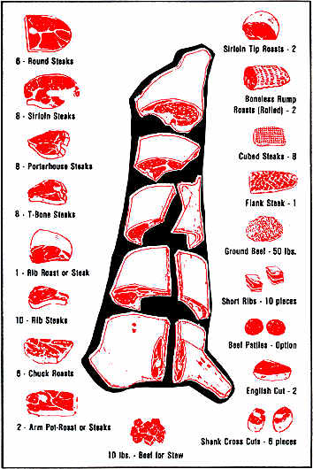
4-Hers planning to participate in the swine and/or beef carcass contests at the Morris County Fair need to designate their animals by June 30th. This will allow the participating locker to reserve space. Designations for the contest can be made by contacting the Extension Office.
Nemaha County Prospect Show
Nemaha County’s Prospect Show will be held on June 10, 2017. Pre- entries are due June 8th $15 per head. Late entries after June 8th will be $25 per head. The Show will be located at the Nemaha County Fairgrounds in Seneca, KS.
Dr. Bob Hines Swine Classic
The 2017 Dr. Bob Hines Kansas Youth Swine Classic will be held July 7-8 in Cico Park at the Rile County Fairgrounds in Manhattan, KS. This two day event includes educational opportunities including a swine skillathon and photography contest, showmanship, and a prospect and market hog show. Entry forms and registration will be due June 25th and will be available soon on the KSU Youth Livestock Program Website. Website: www.youthlivestock.ksu.edu

Livestock Sweepstakes
Kansas 4-H Livestock Sweepstakes will be held August 19-20 on the K State campus in Manhattan, KS. This is the corresponding date to previous years. The 4-H Livestock Sweepstakes event includes the state 4-H livestock judging contest, meat judging contest, livestock skillathon, and livestock quiz bowl. The members who will represent Kansas at the national 4-H contest for each of these events will be selected August 1st. All entries must be made through your local Extension Office. Any questions regarding member eligibility need to be inquired through the local extension office before the entry deadline. Rules and information may be found on June 1st on the KSU Youth Livestock Program website. Website: www.youthlivestock.ksu.edu

Cowley County Spring Sheep

Harvey County Swine Show
Harvey County 4-H/FFA Spring Swine Show will be held on Monday, May 29, 2017 starting at 11:00 a.m. Pre-entries are due postmarked by May 22, 2017. Late fees and day of the show fees are $15 per animal.

Central Kansas District
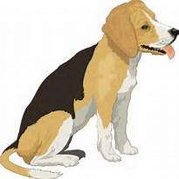
4-H Invitational Dog Show
Central Kansas District 4-H Invitational dog Show will be held on Saturday, June 3rd. This is a state qualifier dog show for the Kansas State Fair 4-H Dog Show for all 4 disciplines at the one show! Registration and more information are available in the Extension Office.

Wild Bill Sheep, Swine,
& Meat Goat Shootout
This year’s Wild Bill Shootout will be held on Saturday, May 13th at the Central Kansas Free Fairgrounds in Abilene, KS. Pre-entries must be postmarked by May 5th. Entry fee is $10/head. Late fees are $15/exhibitor. Show schedule and entry forms are available in Extension Office.

Marshall County Spring Swine Show
2nd Annual Marshall County Spring Swine Show will be held on Saturday May 20th at the fairgrounds in Blue Rapids, KS. Check in will begin at 9am and the show will start at 10am. Pre-registration is due May 10th. Pre-entries are encouraged but not required. Forms are available at: http://www.marshall.k-state.edu/quality-beef-day/index.html

2017 Insect Spectacular
It’s time to get registered for the 25th Insect Spectacular. The State Entomology Workshop will be held Friday and Saturday June 23rd and 24th. We will be hosted by the Sternberg Museum in Hays, KS. For more information and registration forms please contact the Extension Office.

Livestock Judging Camps
The KSU “Champions” Livestock Judging Camp is a three day, intense judging camp designed for 4-H and FFA members, ages 14-18, who are seriously interested in enhancing their livestock judging and oral communication skills. Prior livestock judging experience is necessary for this camp. Workouts will be conducted similar to those at a collegiate level. Mini camps will be conducted in June. Each camp will be limited to 35 students and will be accepted on a “first come-first serve” basis. The following dates are set for the 2017 camps. June 7-9, June 12-14, June 16-18. Registration forms and more information are available in the Extension Office. Registration is due by May 22.

Mark your 2017 Calendars
May 1 – Deadline to add or drop a project
May 1 – Horse ID papers due
May 1 – Foundation Scholarships due
May 1 – Fair T Shirt orders due
May 4 – Cloverbud Meeting
May 15 – Konley Harding Scholarships due
May 15 –Sunny Hills Camp registration due
May 29 – Office Closed for Memorial Day
May 30-June 2 – Discovery Days
May 30- June 2 – Kansas 4-H Sewing Camp
May 31 – Babysitting Clinic
June 5 – 4H Council and Ambassador Mtg
June 6 – Beginners Horse Judging Camp
June 6 – Cat Meeting
June 7-8 – Advanced Horse Judging Camp
June 9-11 – Geology Field Trip
June 23-24 – Insect Spectacular
June 24-27 – Sunny Hills 4-H Camp
June 27-30 – 4-H Campference
July 16-18 – Leadership Unlocked
July 6-8 – Tri County Fair
July 22-31 – Morris County Fair
September 8-17 – Kansas State Fair
September 29-October 1 - KJLS

Livestock Calendar
May 6 – Shawnee County State Wide Livestock Show
May 6-7 – Gary Fuller Spring Classic
May 13 – Cherokee County Livestock Expo & Showdown
May 13 – Wild Bill Shootout
May 20 – Leavenworth County Small Livestock Spring
Show
May 20 – Marshall County Swine Show
May 27 – Cowley County Spring Show
May 27
-28 – Jackson County Spring Show
May 29 – Harvey County Swine Show
June 3 – Central Kansas Invitational Dog Show
June 4 – Ellis County Spring Horse Show
June 7-9 – “Champions” Livestock Judging Camp
June 12-14 – “Champions” Livestock Judging Camp
June 16-18 – “Champions” Livestock Judging Camp
June 10 – Nemaha County Prospect Show
July 7-8 – Dr. Bob Hines Swine Classic
August 19-20 – Livestock Sweepstakes

Memorial Day
The Extension office will be closed on Monday, May 29th in observance of Memorial Day.

Congrats and best wishes to all the graduating
4-Hers!!

