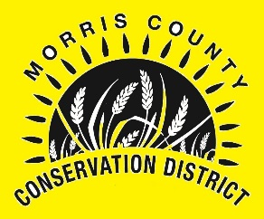
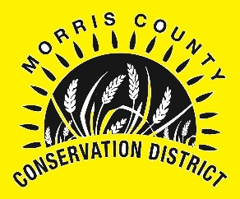
MORRIS COUNTY CONSERVATION DISTRICT
SENIOR HIGH SCHOOL
SCHOLARSHIP APPLICATION

Name of Applicant: ________________________________________________________

Mailing Address: __________________________________________________________

City, State, Zip: ___________________________________________________________

Daytime Phone: ___________________________________________________________

E-Mail Address: ___________________________________________________________

Grade Point Average: _____________________________________________________

High School: ______________________________________________________________

College or University to Attend: _________________________________________

College Major: ____________________________________________________________

$500.00 Scholarship ($250.00 per Semester)
*Copy of Grades with a Minimum of 2.0 GPA Required for 2nd Payment!

ITEMS REQUIRED WITH APPLICATION (Applicant must be pursuing a degree in a natural resource field.) Examples: Range Management, Plant Sciences, Agronomy, Agriculture Technology Management, Animal Science, Ag Education, Feed Science, and any other “natural resource” field.
1. Copy of School Transcript
2. Two Letters of Recommendation (not relatives)

Signature of Applicant _______________________________ Date _________________

On a separate piece of paper, please type a 500 word essay explaining why conservation and water quality are important to you, and tell how this scholarship will benefit you personally and/or professionally. Deadline for applications and all requested materials will be December 20, 2019. Scholarship will be presented at the Morris County Conservation District's Annual Meeting scheduled for January 25, 2020.
.
Submit application to:
Morris County Conservation District
116 Fox Street
Council Grove, KS 66846-1219

For more information or if you have any questions, please contact us at: 620-767-5111 Ext. 101 or contact jobea.titus@ks.nacdnet.net or visit http://www.morriscountyconservationdistrict.com/

*WATER QUALITY *CONSERVATION *DEVELOPMENT *SELF-GOVERNMENT

