Register for Walk Kansas
Go to www.walkkansas.org and click “Register” or select “My Walk Kansas” on left side bar.
At any time, during this process, if you are not ready to advance to the next step (Example: you don’t have a full team yet or don’t have email addresses for all team members) please click “CANCEL.” If you just exit without clicking on “cancel” you will have challenges when you come back and try to register again.

Click the yellow “Register” button.
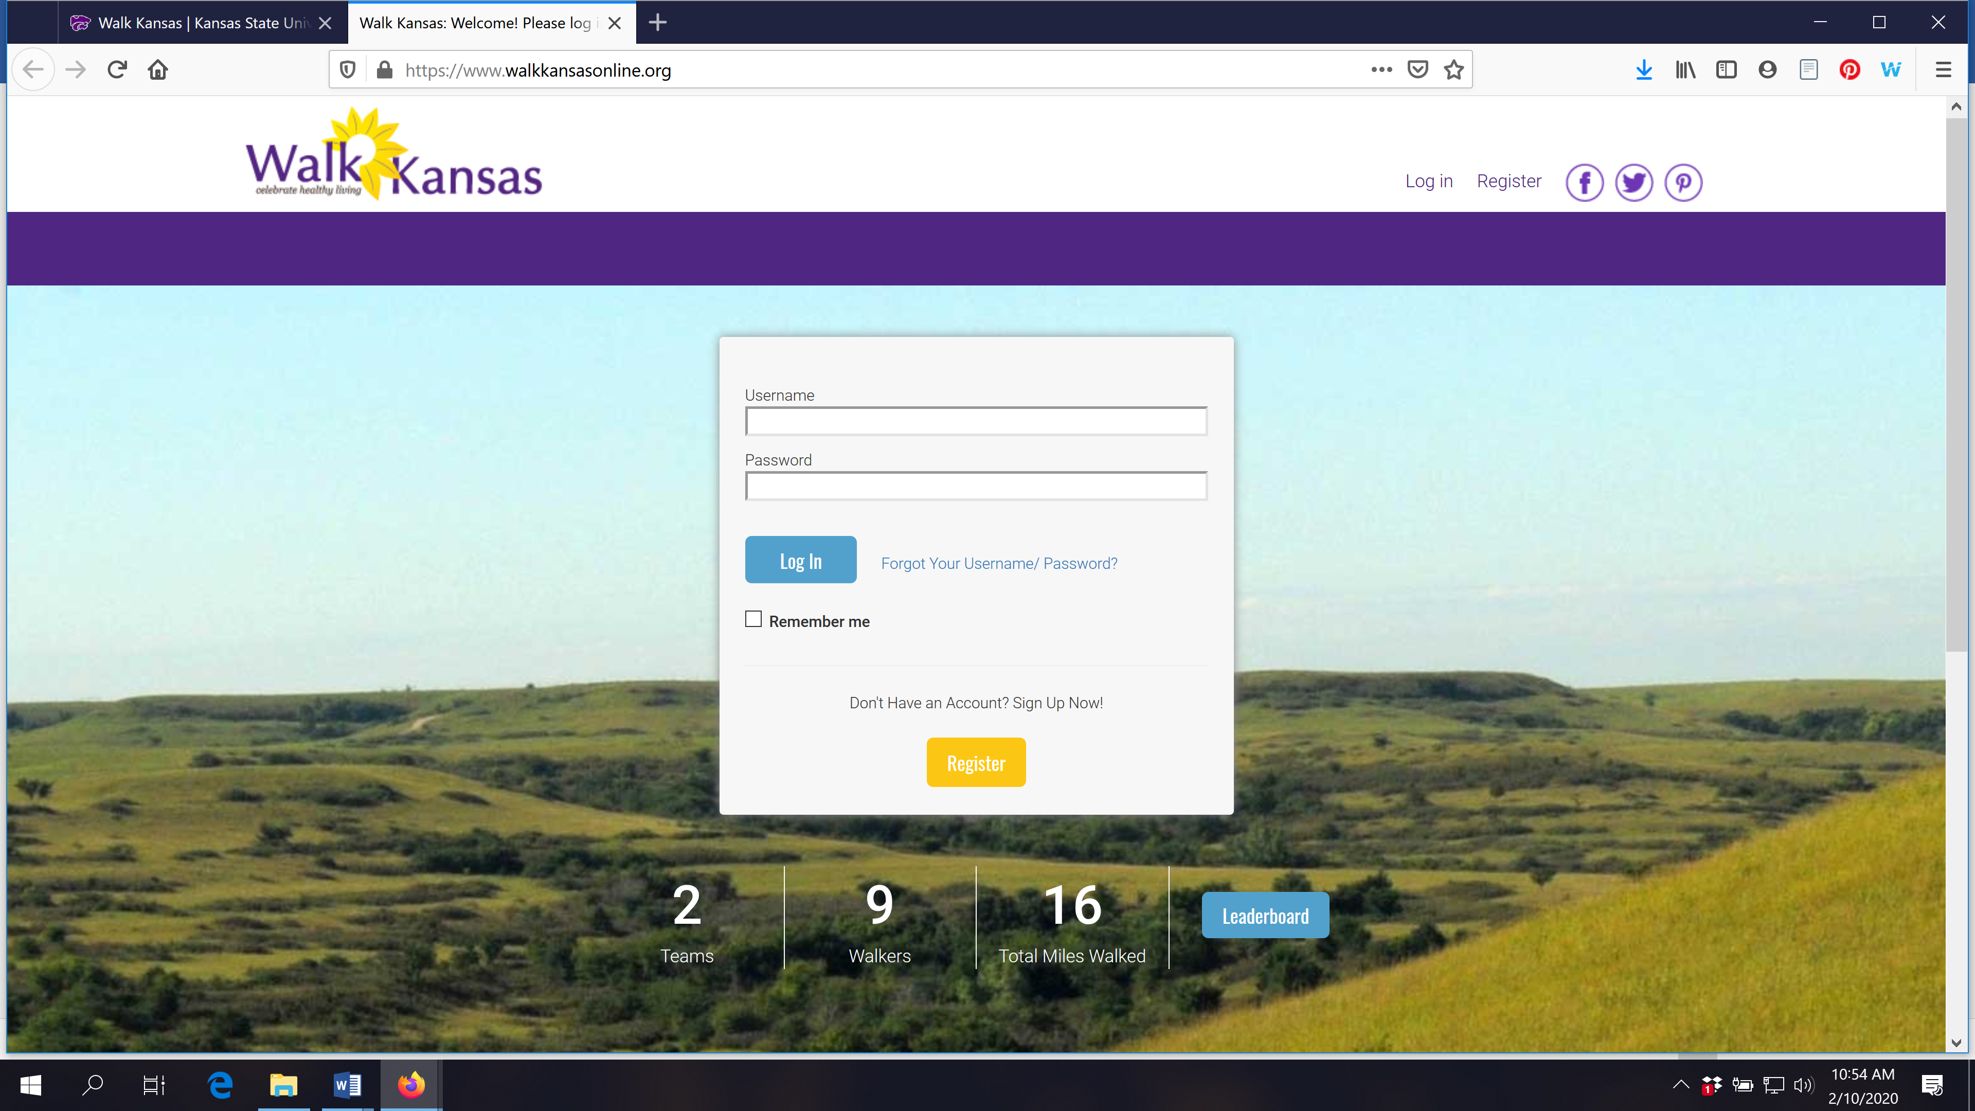

Read the “reminders” on this screen. If you are not ready to register, click “cancel” and if you are ready, click “ready to go!”
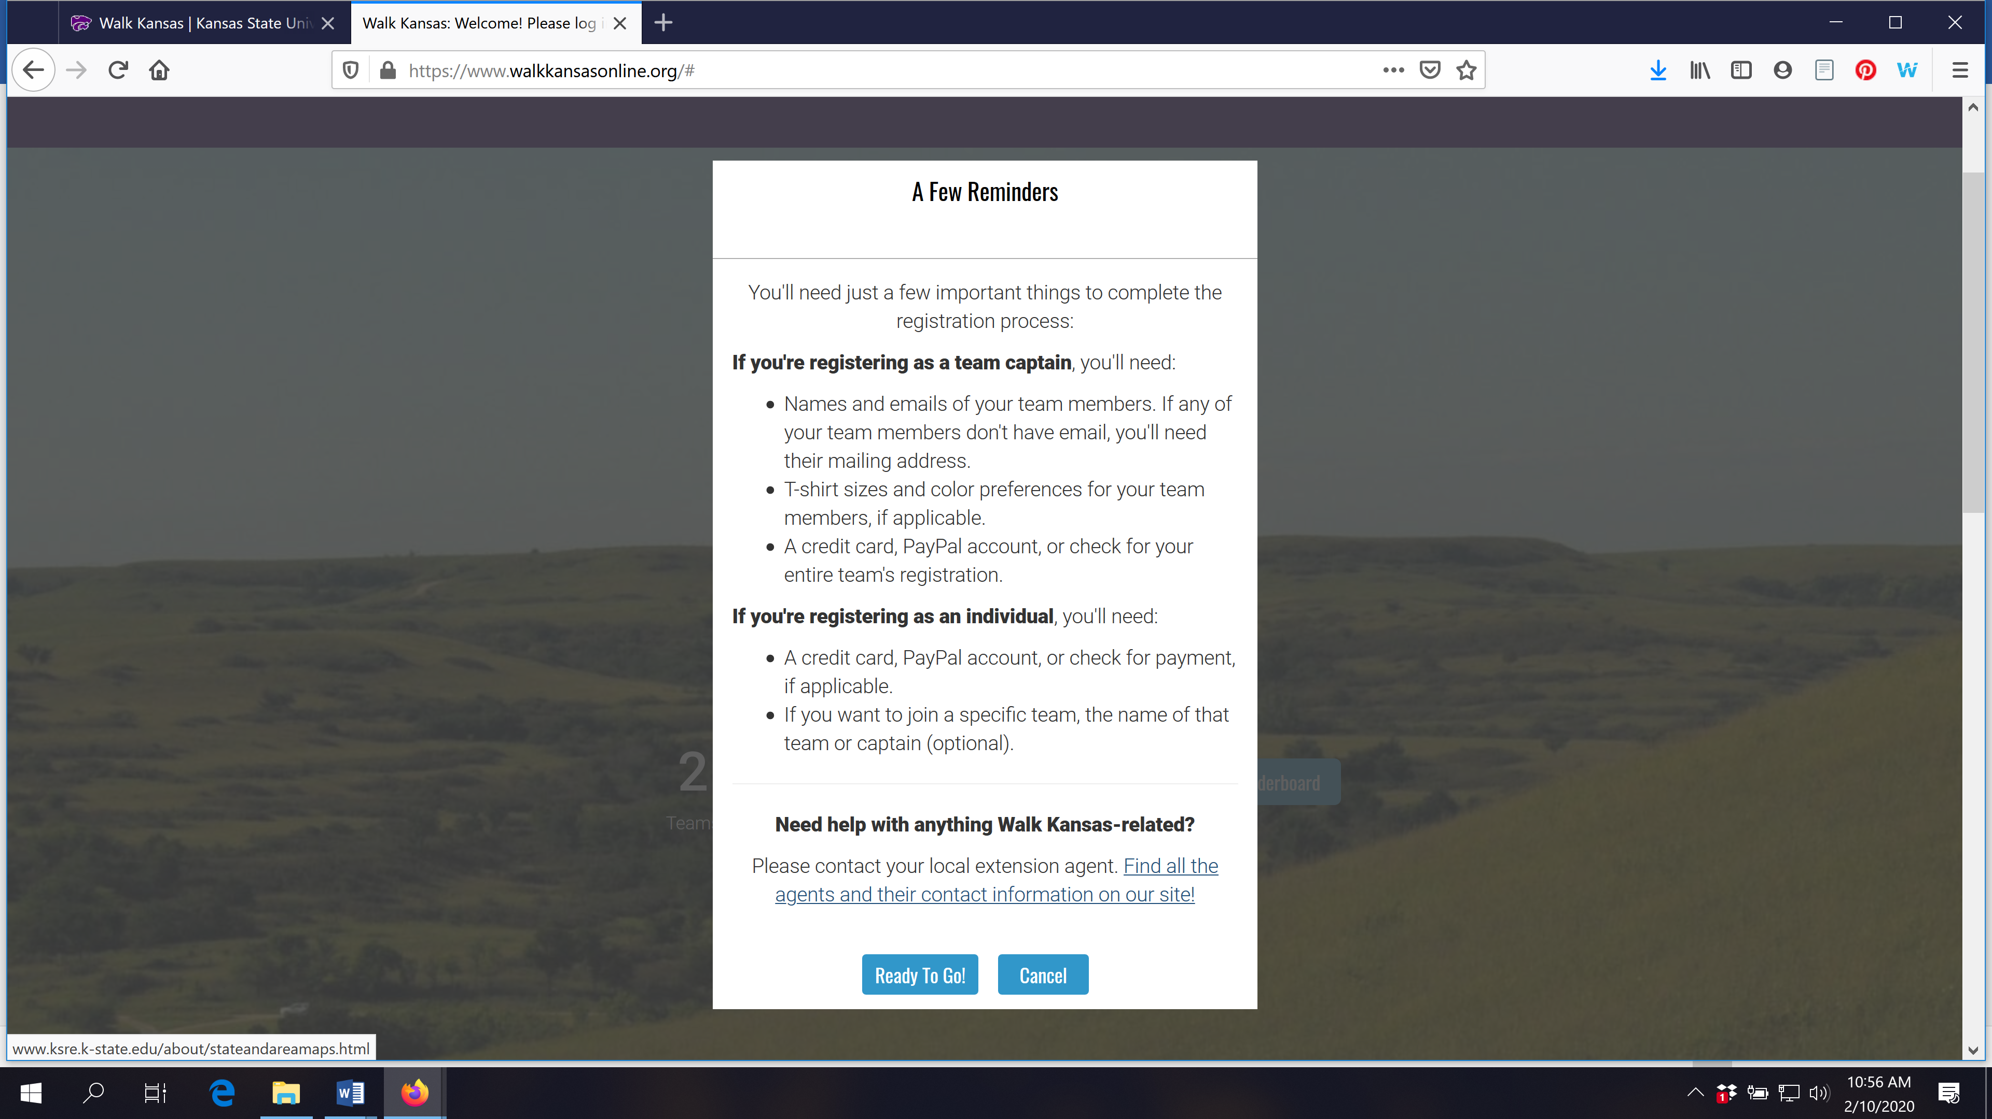
On the next screen, click on the first letter of the county/district/group where you will participate. (Participants are not required to live in the state of Kansas, nor do they need to participate in the county where they live. We are all connected via technology!)

After you select where you will participate, you should see this screen:
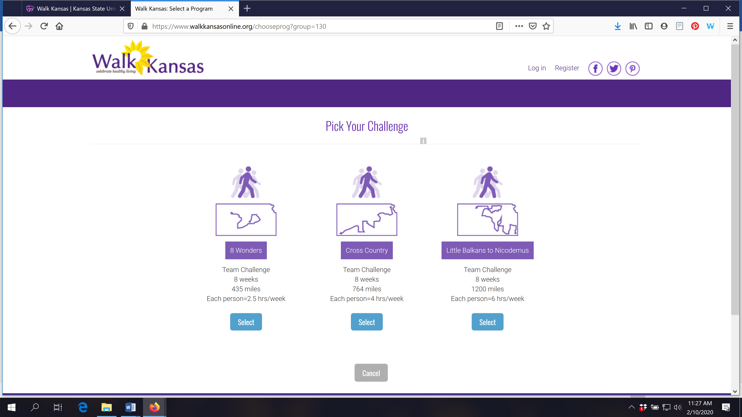
If you are the captain of your team, select the challenge your team has chosen. If you are registering as an individual, select the challenge you would like to work towards and your local Extension agent will connect you with a team that matches your challenge.
While you are on this screen, check the option “Challenge Only” and then you can advance.

This next screen asks you to choose the type of registration. If you are registering your team, select “Team Captain” and if you are registering as an individual and would like to join a team, select “Individual.” Captains will need to select a team name.
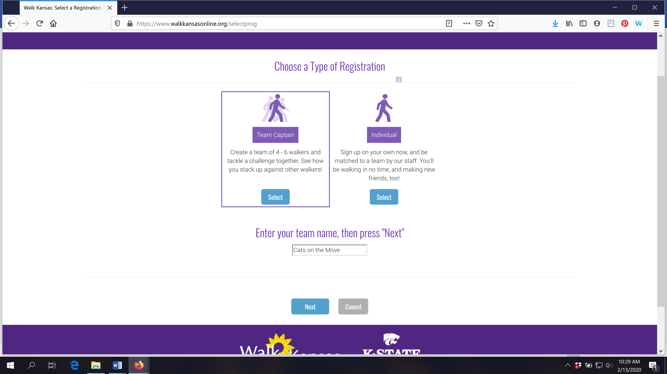
Next, you will create your personal account with a username and password.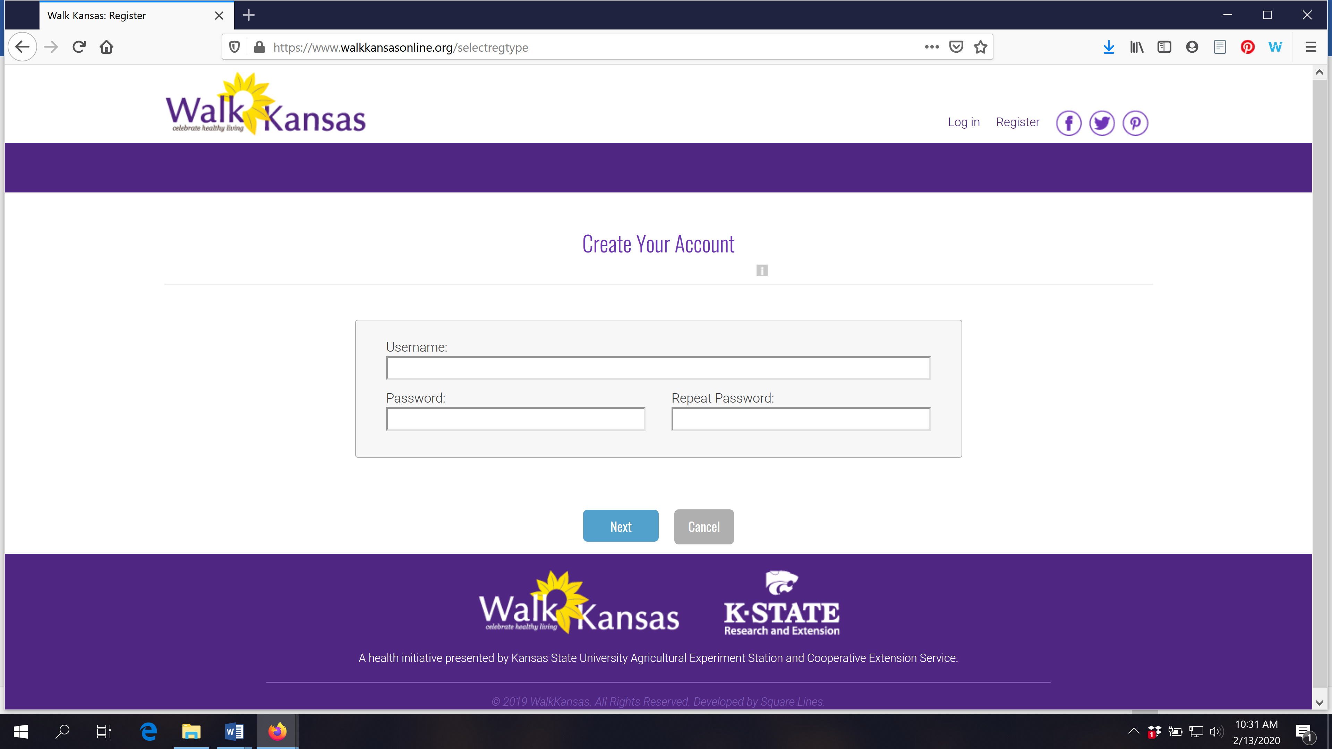
After you click “Next” it will ask for additional information about you.

The next step is to build your team. You must have at least 4 people on your team (including yourself) before you will see the blue “Next” button to advance with registration. Teams must have at least 4 people and 6 is preferred. Click “Cancel” if you do not have at least 4 team members.
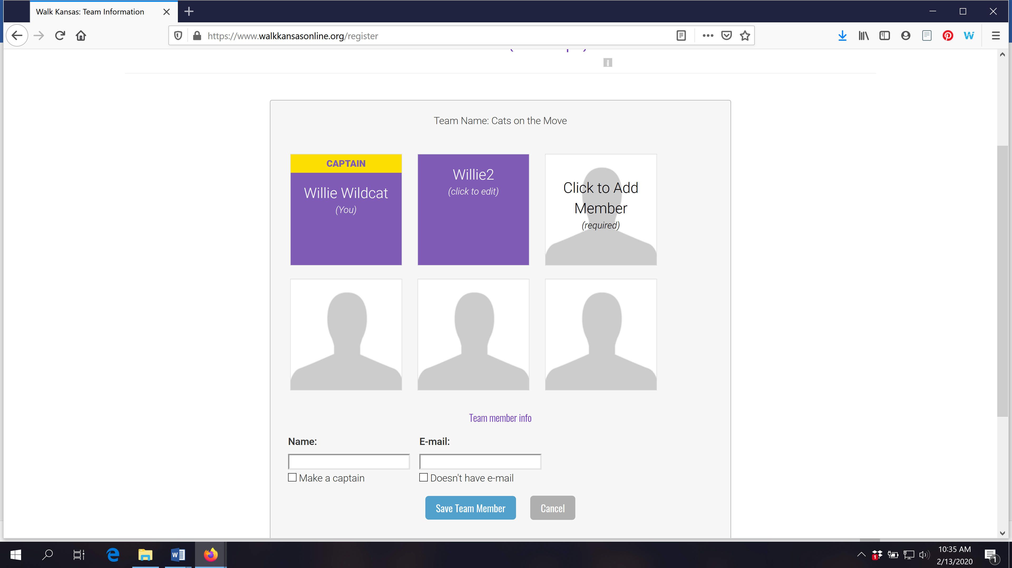
You will see a confirmation screen after you click “Next”
The next screen asks for your consent to participate and to authorize or not authorize photo consent. There also a consent option to participate in a 6-month follow-up survey.
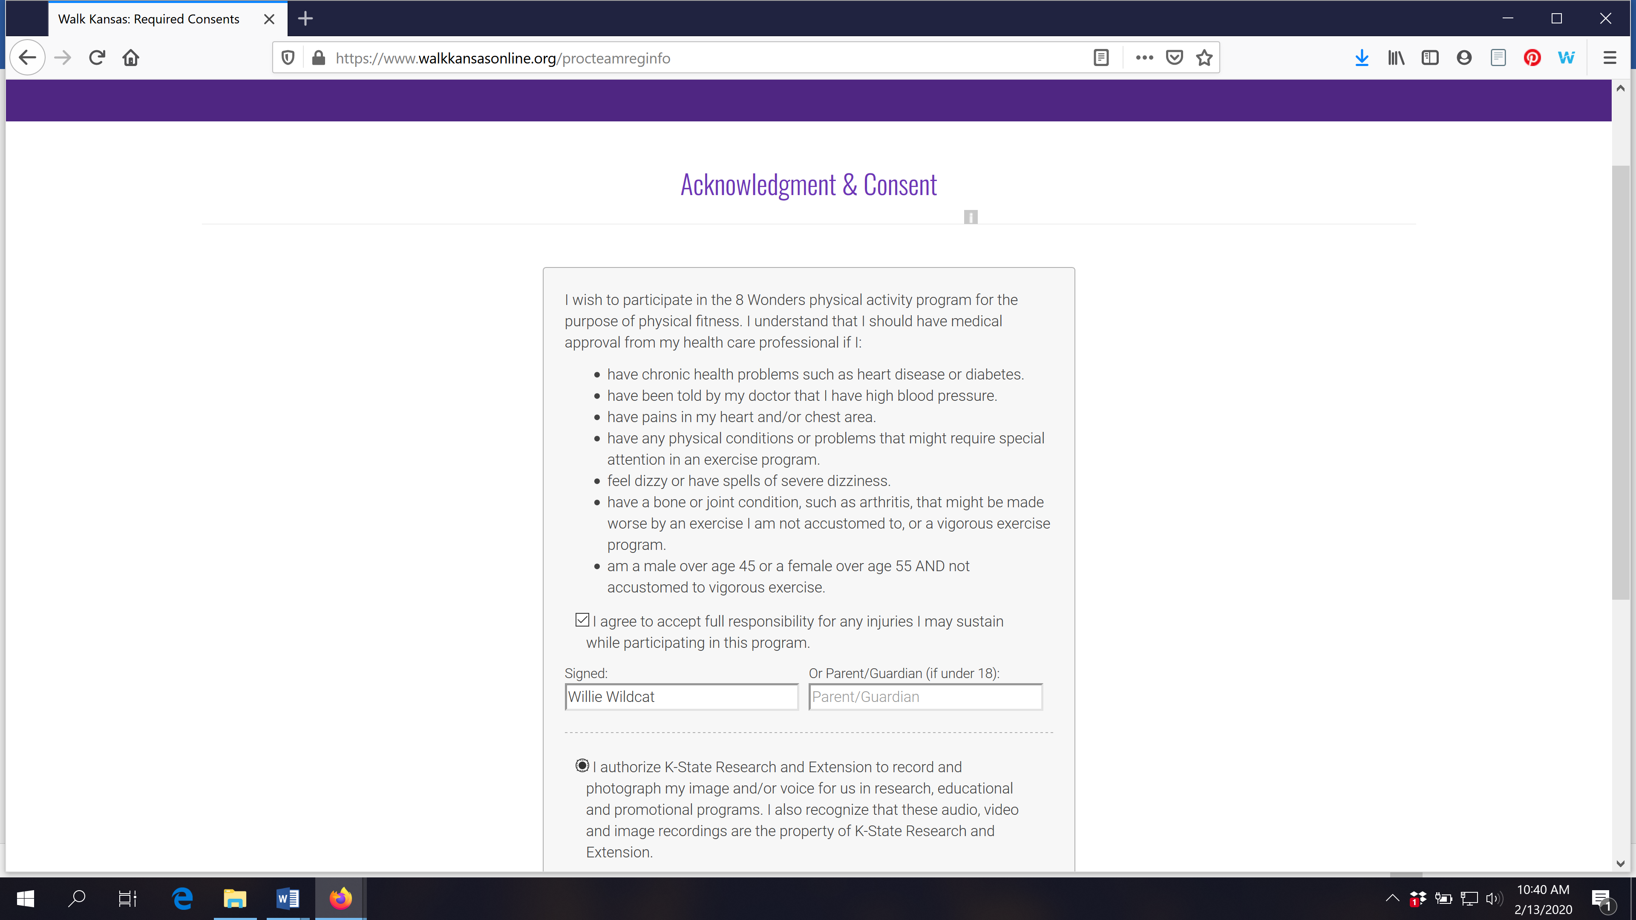

The last screen will show your order and payment options. Some local programs will offer the option to pay online and you must confirm how you will pay to complete registration. Click on the blue “Confirm Payment By Check” or select the online payment option. DO NOT JUST EXIT THIS SCREEN WITHOUT SELECTING A PAYMENT OPTION OR HIT CANCEL TO CANCEL YOUR REGISTRATION. 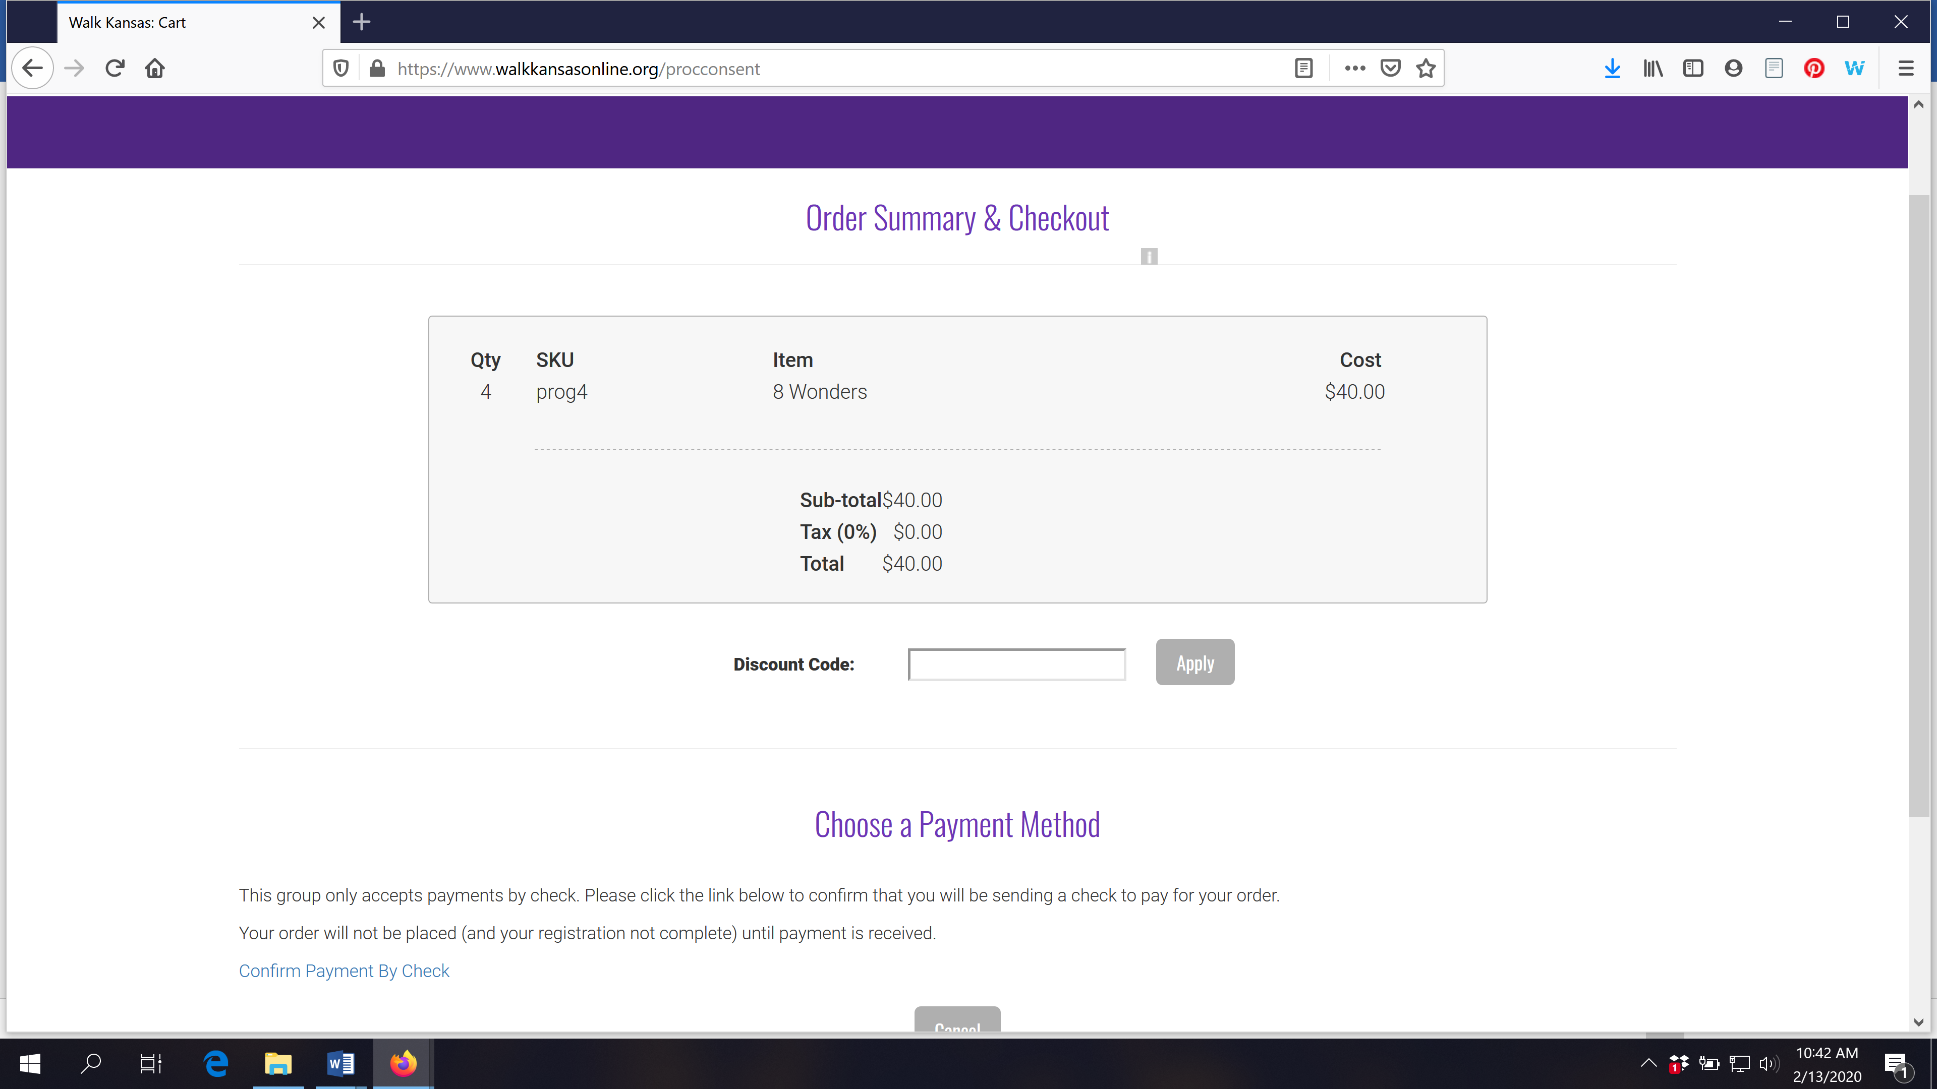

Your registration is complete when you see a screen similar to this:
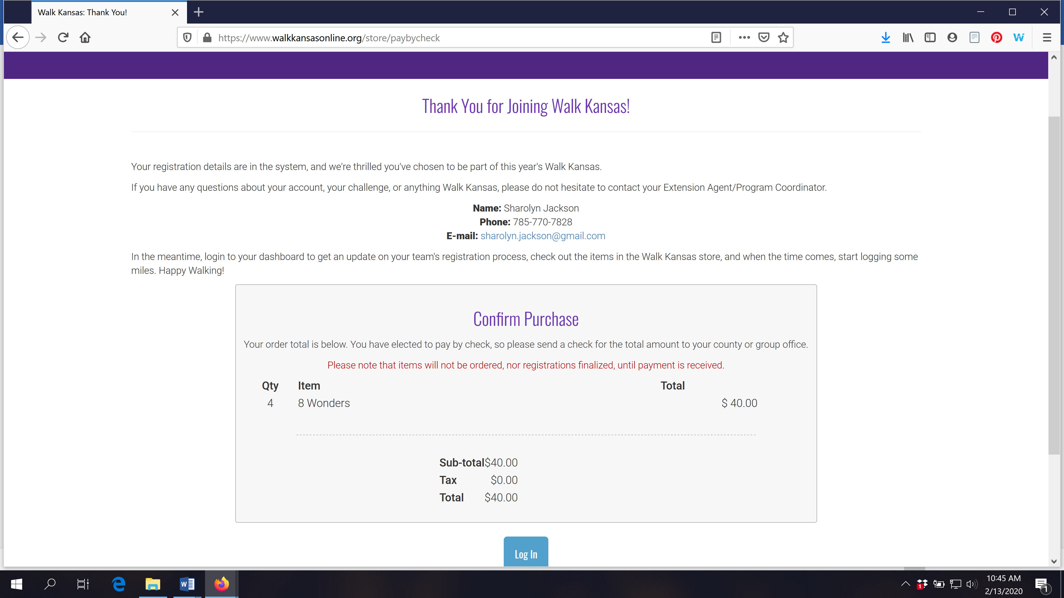

Now you can log in to your account and view your Dashboard. Once you have logged in you can purchase t-shirts and other items from the SHOP.

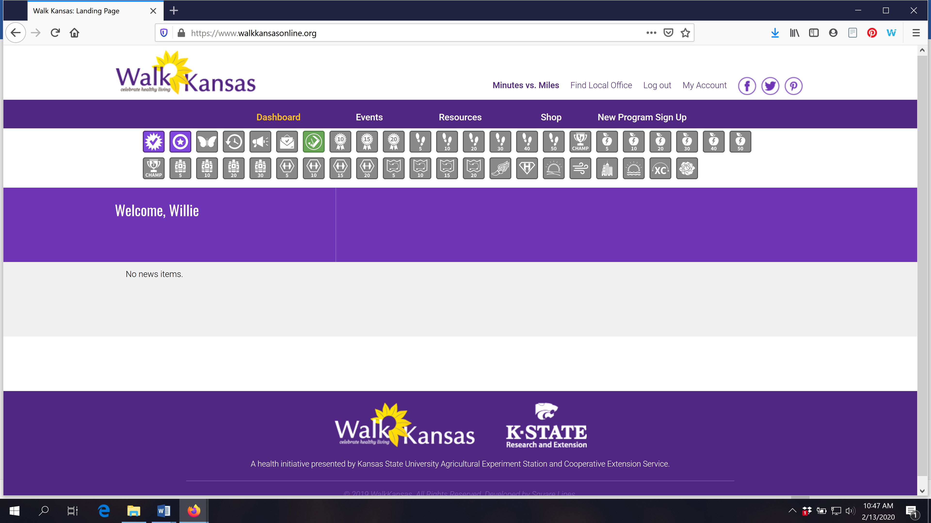

Click the “SHOP” button on the purple bar to enter the online store.
You will see a screen similar to this. T-shirt colors for 2020 are Heather Sea Green and Heather Storm. Youth and adult sizes (sm-4X) are available.
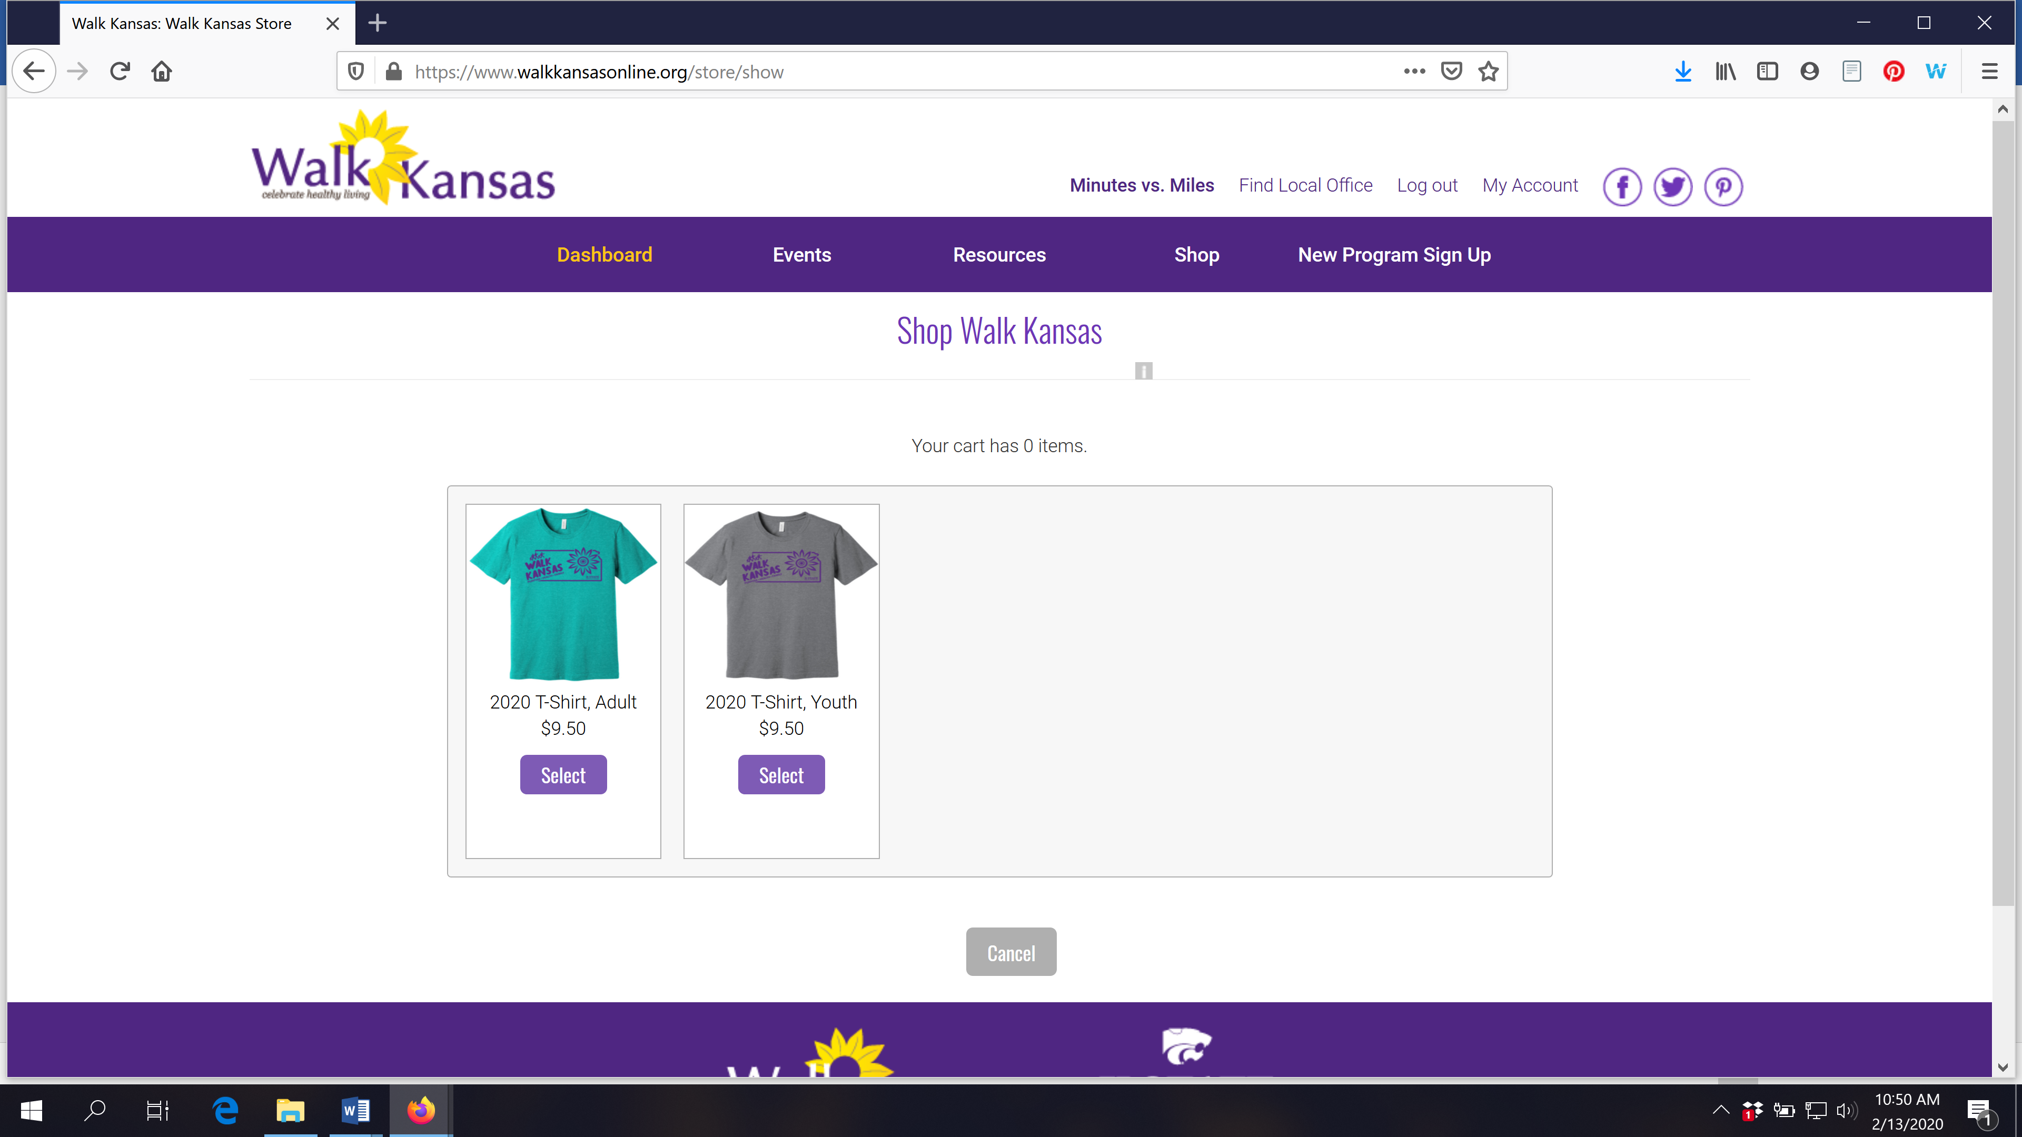

Make your selections (some local programs offer sweatshirts and long-sleeved t-shirts in addition to the program tee.) You will see a similar payment screen as before and then complete your order.

The online Walk Kansas store is open through the first two weeks of the program. Contact your local Extension office with specific questions.

We have an app!
The Walk Kansas app is free and you can download it from the App Store. This is a pilot year so it is available only in iOS format for iPhone and iPad. Watch for the Android version in the future!
You cannot register through the app so wait until your account is set up online first. Then, you can access all of your information and log minutes, etc.
The Walk Kansas app will sync with fitness trackers. However, if you have a Fitbit you will need to download Fitbit to Apple Health Sync ($5.99) for this data transfer.

Using the Walk Kansas app:
- Before you use the app make sure your team is created online, that you have selected a challenge (from the 3 available), and make sure that logging is ready to go and that your team is ready. You may want to test this online first to make sure you can log minutes.
- When you open the app for the first time, you’ll see a splash screen that tells you to login with the username and password you created on the WK website. When you close this screen you will see some login fields.
- After you login, the default screen should be the log activity screen ; click “new log” and have at it!
- To edit an existing log just click the row you want to edit.
- All data entered through the app will transfer to the web and vice versa.

